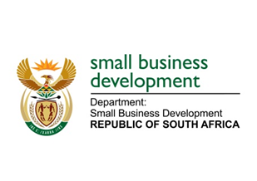
NATIONAL ASSEMBLY
QUESTION FOR ORAL REPLY
DUE TO PARLIAMENT: FRIDAY, 16 JUNE 2023

“2117. Mr J N de Villiers (DA) to ask the Minister of Small Business Development:
Whether her department has undertaken any review and/or study to determine the extent to which small-, medium- and micro enterprises (SMMEs) benefited from the African Growth and Opportunity Act (AGOA) agreement between the Republic and the United States of America; if not, why not; if so, (a) to what extent have SMMEs benefitted from the AGOA in the past three years and (b) what total number of jobs have been created and sustained due to the AGOA?” NW2401E

REPLY:
I have been advised:

The Department of Small Business Development (DSBD) has not undertaken a review as part of its research undertaking on the African Growth and Opportunity Act (AGOA).

The DSBD and the Department of Trade Industry and Competition (the dtic) participated in the South Africa-United States of America (SA-USA) meeting to discuss matters related to the AGOA. The US International Trade Commission (USITC) communicated that they will be conducting assessment on how (extent to which and the impact of) AGOA has assisted/supported growth in the Chemical and Textile Sectors (and other sectors); as well as domestic programmes (funding and capacity building) aimed at supporting Small and Medium-sized Enterprises (SMME) exporters.

AGOA is currently set to expire in 2025. SA is jointly with the African Union lobbying for extension beyond 2025. DSBD and the dtic will embark on a consultation process to formulate a country position on AGOA ahead of the negotiations to ensure that South African SMMEs interests are covered in the new agreement.

(a)&(b) Not applicable.

