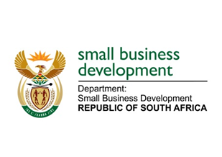
NATIONAL ASSEMBLY
QUESTION FOR ORAL REPLY
DUE TO PARLIAMENT: FRIDAY, 16 JUNE 2023

“2116. Mr H C C Krüger (DA) to ask the Minister of Small Business Development:
Whether her department is implementing any initiatives and/or programmes targeted specifically at fostering an entrepreneurial ecosystem in rural communities, given that entrepreneurship is a recognised catalyst for economic growth; if not, why not; if so, what are the relevant details?” NW2400E

REPLY:
I have been advised:

That the Department of Small Business Development (DSBD) is implementing the Township and Rural Entrepreneurship Programme (TREP) to foster an entrepreneurial ecosystem in rural and township communities. The TREP goal is to overcome the legacy of economic exclusion by creating a conducive environment for entrepreneurial activity and providing dedicated business support to enterprises in rural and township areas including access to funding. TREP supports all small enterprises operating in townships and rural areas to grow their businesses. The programme assists small enterprises with the acquisition of business-related equipment, tools or machinery and working capital. Furthermore, the DSBD is rolling out a network of incubators to ensure that Business Development Support is accessible to small enterprises and co-operatives operating in unserved and underserved areas such as townships and rural area.

Our financial products through Sefa also prioritise rural enterprises as seen in the Sefa disbursements below:
 | Audited Performance over the past financial years
 | 2019/20 | 2020/21 | 2021/22 | 2022/23 (Estimated) | 2023/24 (Target)
Disbursements to enterprises located in rural towns and villages (R’000) | R371 151 | R563 051 | R977 100 | R766 765 | R938 636

