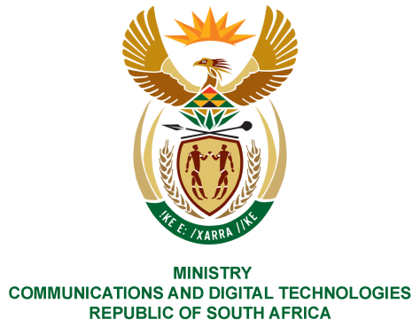
PARLIAMENT OF THE REPUBLIC OF SOUTH AFRICA
NATIONAL ASSEMBLY
WRITTEN REPLY

QUESTION NO: 2116
DATE OF PUBLICATION: 4 September 2020
QUESTION PAPER NO: 35

Ms P van Damme (DA) to ask the Minister of Communications:

What total amount has the SA Broadcasting Corporation spent on (a) catering and (b) entertainment in the past two financial years?
NW2678E

REPLY:

I have been advised by SABC as follows:

Year | (a) Catering | (b) Entertainment
2019/20 | R2 973 768,65 | 0
2018/19 | R3 106 635,82 | 0
TOTAL | R6 080 404,47 | 0

MS. STELLA NDABENI-ABRAHAMS, MP
MINISTER OF COMMUNICATIONS AND DIGITAL TECHNOLOGIES

