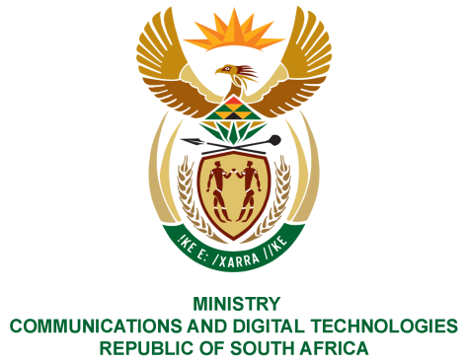

PARLIAMENT OF THE REPUBLIC OF SOUTH AFRICA
NATIONAL ASSEMBLY
WRITTEN REPLY

QUESTION NO: 2115
DATE OF PUBLICATION: 4 SEPTEMBER 2020
QUESTION PAPER NO: 35

Ms P van Damme (DA) to ask the Minister of Communications:

Whether any alcoholic beverages were purchased in the past three financial years with any official credit card issued to any staff member employed by any entity reporting to her; if not, what is the position in this regard; if so, (a) what (i) are the relevant details and (ii) is the value of the specified purchases in each case and (b) for what purpose was each purchase made?
NW2677E
REPLY:

I have been advised by entities in the DCDT portfolio as follows:

No alcohol was purchased using any official credit card in the past three financial years.

MS. STELLA NDABENI-ABRAHAMS, MP
MINISTER OF COMMUNICATIONS AND DIGITAL TECHNOLOGIES

