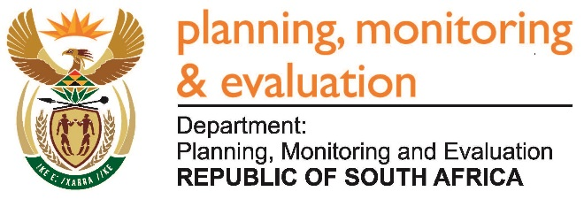 |  | 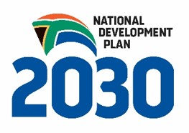
Private Bag X944, PRETORIA, 0001. Union Buildings East Wing, Government Avenue, PRETORIA
Tel: 012 312 0307. www.dpme.gov.za
______________________
NATIONAL ASSEMBLY
QUESTIONS FOR WRITTEN REPLY

2115. Mr A R McLoughlin (DA) to ask the Minister in The Presidency:

What amount did (a) his Office and (b) each entity reporting to him spend on advertising on the (i) Africa News Network 7 channel, (ii) SA Broadcasting Corporation (aa) television channels and (bb) radio stations, (iii) national commercial radio stations and (iv) community (aa) television and (bb) radio stations (aaa) in the 2015-16 financial year and (bbb) since 1 April 2016? NW2426E

Reply:
The Department of Planning, Monitoring and Evaluation has not spent any money on advertising on any television or radio station in the financial year 2015-16, and in the current financial year from 1 April 2016 to date. Statistics South Africa spent R1 991 927. 60 on SA Broadcasting Corporation television and radio.

