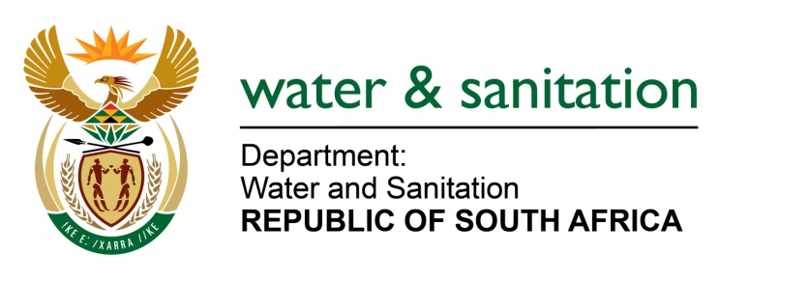

NATIONAL ASSEMBLY

FOR WRITTEN REPLY

QUESTION NO 2113

DATE OF PUBLICATION IN INTERNAL QUESTION PAPER: 23 SEPTEMBER 2016
(INTERNAL QUESTION PAPER NO. 29)

2113. Mr C D Matsepe (DA) to ask the Minister of Water and Sanitation:

What amount did (a) her department and (b) each entity reporting to her spend on advertising on the (i) Africa News Network 7 channel, (ii) SA Broadcasting Corporation (aa) television channels and (bb) radio stations, (iii) national commercial radio stations and (iv) community (aa) television and (bb) radio stations (aaa) in the 2015-16 financial year and (bbb) since 1 April 2016? NW2424E
---00O00---

REPLY:

(a) My Department has spent R37 800 269.05 in 2015/2016 and R6 840 941.20 since 1 April 2016 to date on advertising. Below is the breakdown as per request
- African News Network 7 channel
Item | 2015/2016 | 1 April to date
(aa) television channels | R0.00 | R0.00
(bb) radio stations | R450 000.00 | R0.00
- SA Broadcasting Corporation
Item | 2015/2016 | 1 April to date
(aa) television channels | R22 528 202 | R2 508 000
(bb) radio stations | R14 727 256.68 | R2 499 712.20
- National commercial radio stations
Item | 2015/2016 | 1 April to date
(aa) television | R0.00 | R0.00
(bb) radio station | R0.00 | R1833 229
- Community
Item | 2015/2016 | 1 April to date
(aa) television | R0.00 | R0.00
(bb) radio station | R94 810.37 | R0.00
(b) Refer to Annexure A.

Annexure A

Below is the breakdown for entities as per request:

(b) Entities | (i) | (ii) | (aa) | (bb) | (iii) | (iv) | (aa) | (bb) | (aaa) | (bbb)
Amatola Water | None | None | None | None | None | None | None | None | None | None
Bloem Water | None | None | None | None | None | None | None | None | None | None
Lepelle N Water | None | SABC Limpopo Combo | Thobela FM; Phalaphala FM and Munghanalonene | R160 717,21 | Capricorn FM | R68 400,00 | None | R68 400,00 | None | R68 400,00
Magalies Water | None | R53 530.00 | None | R53 530.00 | None | R9 700.00 | None | R9 700.00 | R63 230 00 | None
Mhlathuze Water | None | None | None | None | None | None | None | None | None | None
Overberg Water | None | None | None | None | None | None | None | None | None | None
Rand Water | None | R 5 221 600 SABC Total | R 4 818 400 SABC TV | R 403 200 SABC Radio | R 586 515 Commercial Radio | R 161 758 Community Total | None | R 161 758 Community Radio | R 5 785 613 for 2015-16 | R 184 260 since Apr 2016
Sedibeng Water | None | None | None | None | None | None | None |  | 1 July 2016 – 30 March 2016: R523 387.80 | 1 April 2016 – 31 August 2016:R218 078.30
Umgeni Water | None | None | None | None | None | R135 000 (Community radio stations in July 2016) | None | None | None | R135 000 (Community radio stations in July 2016)

---00O00---

