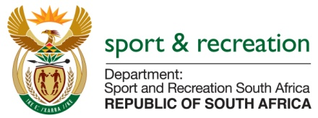

PARLIMENTARY QUESTIONS FOR THE MINISTER

Question Numbers 2107 from Mr. E.J. Marais (DA) to ask the Minister of Sport and Recreation

- What amount did (a) his department and (b) each entity reporting to him spend on advertising on the (i) Africa News Network 7 channel (ii) SA Broadcasting Corporation (aa) television channels and (bb) radio stations, (iii) national commercial radio stations and (iv) community (aa) television and (bb) radio stations (aaa) in the 2015 -16 financial year and (bbb) since 1 April 2016?

NW2418E
REPLY
The department spent as follows for advertising:
- -16 Since 1 April 2016

Africa News Network 7 Channel R0.00 R0.00

SA Broadcasting Corporation
- Television channel R1 569 408.15 R0.00
- Radio channel R0.00 R0.00

National Commercial Radio Stations R0.00 R0.00

Community
- Television R0.00 R0.00
- Radio Stations R60 310.00 R0.00

