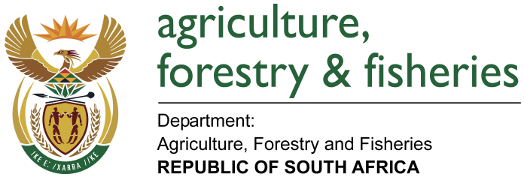
NATIONAL ASSEMBLY

WRITTEN REPLY

QUESTION 2106 / NW 2336E

MINISTER OF AGRICULTURE, FORESTRY AND FISHERIES:
Mr L S Tlhaole (EFF) to ask the Minister of Agriculture, Forestry and Fisheries:

QUESTION:
Whether his department has a policy in place to protect farmer seed systems that (a) recognises farmers’ rights, (b) sets out the government’s vision in relation to evolutionary plant breeding, (c) assists with regard to the production of farmers’ varieties in partnership with farmers and (d) lays out a vision for farmers and their systems to be part of the South African seed system and/or sector; if not, in each case, why not; if so, in each case, what are the relevant details? NW2336E
REPLY:

(a) The Department protects farmer seed systems through the implementation of the National Programme on Conservation and Sustainable Use of Genetic Resources for Food & Agriculture. As an outflow of this programme, the Departmnt is currenty implementing the National Plan on Conservation and Sustainable Use of Plant Genetic Resources for Food and Agriculture. This Plan aims to address most of the obligations placed on Contracting Parties to the International Treaty on Plant Genetic Resources for Food and Agriculture towards realising Farmer’s Rights. Other obligations such as protection of traditional knowledge are covered in legislation and programmes of the departments of Environmental Affairs and Science & Technology.

(b), (c), (d) The National Plan on Conservation and Sustainable Use of Plant Genetic Resources for Food and Agriculture supports both participatory breeding and promoting the value of farmer’s varieties/ landrace species and underutilised species. Implementation of the plan will proceed in a stepwise manner as funding becomes available.

DAFF together with the provincial departments of agriculture is supporting the participation of smallholder farmers in community seed schemes. These schemes are geared at ensuring that farmers are able to produce certified seed. The initiative involve the training of extension officers as seed inspectors. The extension officers will thus support farmers in terms of adhering to the regulatory requirement for certified seed. The farmers would thus be able to sell their seed in the formal seed markets both locally and for export.

