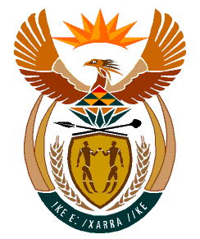

MINISTRY
HUMAN SETTLEMENTS
REPUBLIC OF SOUTH AFRICA

Private Bag X645, Pretoria, 0001. Tel: (012) 421 1309, Fax: (012) 341 8513

Private Bag X9029, Cape Town, 8000. Tel (021) 466 7603, Fax: (021) 466 3610

NATIONAL ASSEMBLY
QUESTION FOR WRITTEN REPLY
QUESTION NUMBER: PQ 2103 [NW2508E]

DATE OF PUBLICATION: 27 MAY 2022

Ms. E L Powell (DA) to ask the Minister of Human Settlements:

What are the details of (a) all contracts awarded by the (i) KwaZulu-Natal Provincial Department of Human Settlements and (ii) eThekwini Metropolitan Municipality using funds from her department in response to the KwaZulu-Natal flood disaster to date and (b) the (i) names of the companies and/or service providers who were awarded the contracts and (ii) values of each contract?

Reply

Based on the report submitted by the KwaZulu-Natal Provincial Department of Human Settlements as of 30 May 2022, the required information is as follows:

