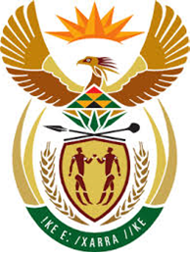

DEPARTMENT: PUBLIC ENTERPRISES
REPUBLIC OF SOUTH AFRICA

NATIONAL ASSEMBLY
QUESTION FOR WRITTEN REPLY
QUESTION 2102

2102. Mr. R A Lees (DA) to ask the Minister of Public Enterprises:
What are the details of the (a) sources of the funds and (b) progress made to obtain the funding required for the implementation of the business rescue plan of the SA Airways (SAA) that was approved by the SAA creditors on 14 July 2020? NW2662E
Reply:
- Various sources of funding are being considered including the strategic equity partner, application for funding from Government through the Medium-Term Expenditure Framework process, approaching Development Financial Institutions and Commercial Banks.
- The process has reached an advanced stage, which we will be able to announce in due course. Due to the sensitive nature of these negotiations we are unable to pronounce at this stage.

