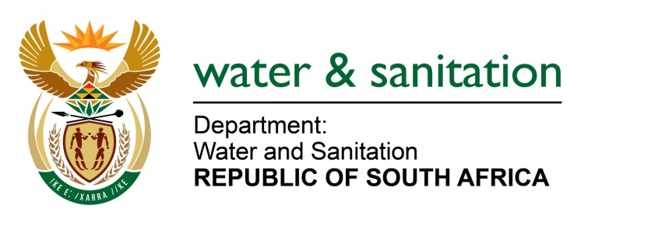

NATIONAL ASSEMBLY

FOR WRITTEN REPLY

QUESTION NO 2101

DATE OF PUBLICATION IN INTERNAL QUESTION PAPER: 02 JUNE 2023
(INTERNAL QUESTION PAPER NO. 21)
2101. Mrs M R Mohlala (EFF) to ask the Minister of Water and Sanitation:
Whether he is responsible for water provision to marginalised communities in municipalities; if not, what is the position in this regard; if so, what (a) measures has he put in place to prioritise the needs of the marginalised communities such as those in the Zakheni Village in the Thembisile Hani Local Municipality, in Mpumalanga, where residents have been experiencing the water crisis and have been deprived of consistent running water for three years and (b) immediate actions have been taken to ensure access to the fundamental right and work towards a sustainable solution, considering the social and economic challenges faced by the marginalised and oppressed of the society? NW2260E
---00O00---
MINISTER OF WATER AND SANITATION

The roles of the Department of Water and Sanitation (DWS) are defined in the National Water Act and Water Services Act. DWS is the regulator of the sector, issues water use licenses, and has responsibilities relating to water resource planning and catchment management. Water provision to marginalised communities in municipalities is the responsibility of municipalities. However, the Department has a responsibility to support municipalities, this includes providing allocation to municipalities from the Water Services Infrastructure Grant (WSIG) and the Regional Bulk Infrastructure Grant (RBIG).

The DWS engaged the Thembisile Local Municipality and they confirmed that the pipeline supplying Zakheni village was damaged by the floods for a period of three (3) to four (4) months which affected water supply. The status is reported as follows:
- The contractor was appointed, and repairs to the damaged pipeline were completed on 30 April 2023.
- Water has been restored in the area and is supplied on rationing scheduling.
- Other areas still receive water through the water tanks to augment the unconnected or unserved areas.
- The municipality is building a new reticulation pipeline.
- The long-term water supply plans for the area are as follows: The Thembisile Hani Local Municipality is supplied by Rand Water and the City of Tshwane based on agreed contracts as it does not have a dedicated water source to supply water to the residents of the municipality. The water supply contracts with Tshwane and Rand Water are under review to increase the current water supply.
- The community of KwaMhlanga and Zakheni will also benefit from the Loskop Bulk water supply scheme once it is completed. The anticipated completion of the project is planned for November 2024.

---00O00---

