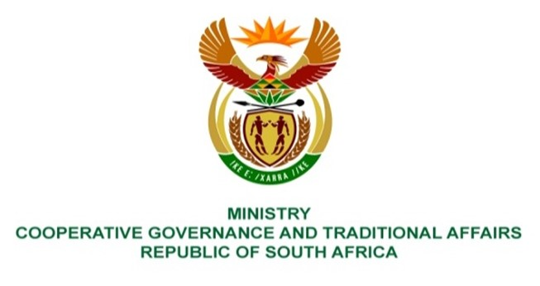

NATIONAL ASSEMBLY
QUESTION FOR WRITTEN REPLY

QUESTION NUMBER 2100
DATE OF PUBLICATION: 27 MAY 2022

QUESTION:

2100. Ms E R J Spies (DA) to ask the Minister of Cooperative Governance and Traditional Affairs:
Whether (a) her department and (b) any of the entities reporting to her have found any ghost workers within their system in the past five years; if not, what is the position in this regard; if so, what (i) total number of ghost workers was discovered, (ii) total amount was paid to them and (iii) steps have been taken to (aa) recover the money lost and (bb) hold the offending parties accountable? NW2505E

REPLY:
a. Department of Cooperative Governance & MISA

During the last five years, the Department has found no ghost workers within its system. No ghost employees were found within the Department of Cooperative Governance and MISA in the past five years. The department and MISA conducts regular employee verification and ensures payroll certification by employees monthly.
b.Community Work Programme
(i) & (ii) The Department identified that some implementing agents made payments to 909 deceased participants totalling R2,483,605.50.
(iii) Payments to deceased participants are being recovered from CWP Implementing Agents.

