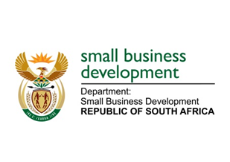
NATIONAL ASSEMBLY
QUESTION FOR WRITTEN REPLY
DUE TO PARLIAMENT: FRIDAY, 26 FEBRUARY 2021

“21. Mr D F Mthenjane (EFF) to ask the Minister of Small Business Development:
What (a) total amount of the budgeted COVID-19 relief fund for small businesses has been distributed to date and (b) is the racial profile of the businesses to which the specified funds were distributed?” NW22E

REPLY:

- Disbursements under the SMME Debt Relief Fund amounted to R316.2 million to 1 151 SMMEs of the R513 million that was set aside. It must be noted that no additional claims from approved beneficiaries were received against the Scheme when the economy moved to lockdown level 3.
- The racial profile of the businesses is outlined as follows:
Race | Number | %
Asian | 3 | 0.26
Black | 696 | 60.47
Coloured | 67 | 5.82
Indian | 98 | 8.51
White | 287 | 24.93
Total | 1 151 | 100.00

