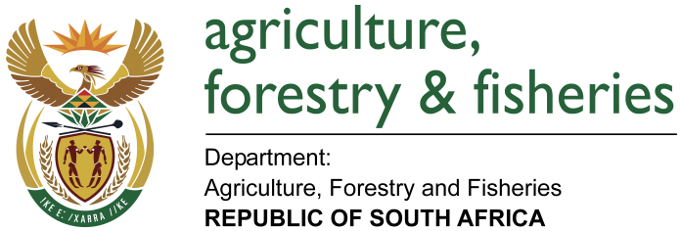
NATIONAL ASSEMBLY

WRITTEN REPLY

QUESTION 2098 / NW 2320E

MINISTER OF AGRICULTURE, FORESTRY AND FISHERIES:
Mr M S Mbatha (EFF) to ask the Minister of Agriculture, Forestry and Fisheries:

QUESTION:
(a) How many beneficiaries are there for the input supply programmes and/or projects of the farmer support programmes according to (i) verified numbers, (ii) gender and (iii) municipality, (b) what are the selection criteria for beneficiaries and (c) who determines the beneficiaries? NW2320E
REPLY:

(a) The input supply programme of DAFF is implemented through the Ilima/Letsema conditional grants. The following is the response based on the verified 2016/17 Ilima/Letsema annual report.
- 214 952 beneficiaries were reported to have been supported with inputs to produce their own food in the 2016/17 financial year.
- In terms of gender, the table 1 below indicates that 47% were male and 53% female.
- Municipalities supported are reflected Annexure A attached.

(b) The criteria for support is as follows:
  - The applicant must be a South African citizen,
  - The applicant must be from a historically disadvantaged group (black, Indian, coloured and Chinese as determined),
  - The applicant must be 18 years or older,
  - Must have proof of tenure,
  - Must have access to services in particular water,
  - Provide the status of farm governance system,
  - Indicate managerial and technical skills.

Documents required to finalise the approval for support are the following:
- Identity document,
- Proof of residence,
- Proof of legal access to land,
- Extension officer’s report,
- Proof of access to water rights where applicable.

(c) The beneficiaries are determined by the approval committees at district level in provinces.

