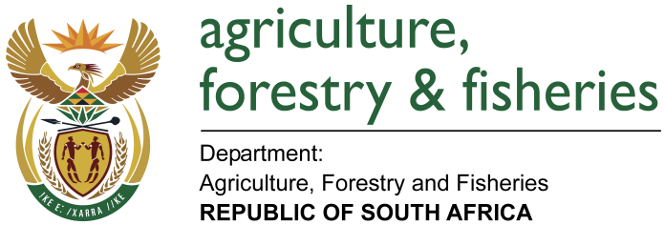

NATIONAL ASSEMBLY

WRITTEN REPLY

QUESTION 2081 / NW2392E

MINISTER OF AGRICULTURE, FORESTRY AND FISHERIES:
THE LEADER OF THE OPPOSITION (DA) TO ASK THE MINISTER OF AGRICULTURE, FORESTRY AND FISHERIES

QUESTION:
(a) What amount did (i) his department and (ii) each entity reporting to him spend on advertising on the (i) Africa News Network 7 channel, (ii) SA Broadcasting Corporation (aa) television channels and (bb) radio stations, (iii) national commercial radio stations and (iv) community and (iv) community (aa) television and (bb) radio stations (aaa) in the 2015-16 financial year and (bbb) since 1 April 2016?
REPLY:

2015 - 2016
(a)
(i) Africa News Network 7 channel = R0
(ii) SABC (aa) television channels = R706 800.00
(bb) radio stations = R822 462.12
(iii) Commercial radio = R111 615.94
(iv) Community (aa) television = R0
(bb) radio = R0

TOTAL = R1 640 878.06

1 APRIL 2016 TO DATE

TOTAL 727 213.30

