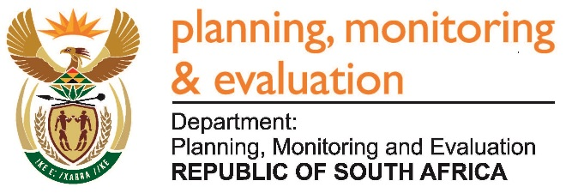 |  | 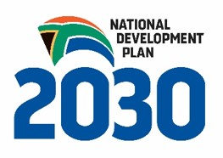
Private Bag X944, PRETORIA, 0001. Union Buildings East Wing, Government Avenue, PRETORIA
Tel: 012 312 0307. www.dpme.gov.za
______________________
NATIONAL ASSEMBLY
QUESTIONS FOR WRITTEN REPLY

2080. Ms S P Kopane (DA) to ask the Minister in the Presidency:
(1) Whether each Head of Department (HoD) of his department signed a performance agreement since their appointment; if not, (a) what is the total number of HoDs who have not signed performance agreements, (b) what is the reason in each case, (c) what action has he taken to rectify the situation and (d) what consequences will the specified HoD face for failing to sign the performance agreements; if so, (i) when was the last performance assessment of each HoD conducted and (ii) what were the results in each case;
(2) whether any of the HoDs who failed to sign a performance agreement received a performance bonus since their appointment; if not, what is the position in this regard; if so, (a) at what rate and (b) what criteria were used to determine the specified rate;
(3) Whether any of the HoDs who signed a performance agreement received a performance bonus since their appointment; if so, (a) at what rate and (b) what criteria were used to determine the rate? NW2391E

Reply:

The Acting Head of Department of Planning, Monitoring and Evaluation has signed a performance agreement the Acting DG has not received a performance bonus.

