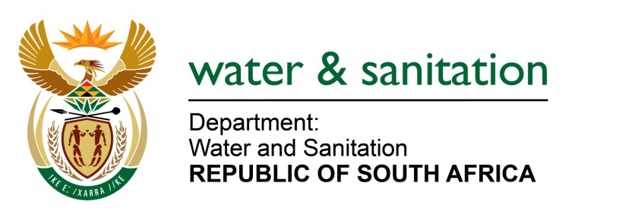

NATIONAL ASSEMBLY

FOR WRITTEN REPLY

QUESTION NO 2078

DATE OF PUBLICATION IN INTERNAL QUESTION PAPER: 23 SEPTEMBER 2016
(INTERNAL QUESTION PAPER NO. 29)

2078. Ms S V Kalyan (DA) to ask the Minister of Water and Sanitation:
(1) Whether each Head of Department (HOD) of her department signed a performance agreement since their appointment; if not, (a) what is the total number of HODs who have not signed performance agreements, (b) what is the reason in each case, (c) what action has she taken to rectify the situation and (d) what consequences will the specified HOD face for failing to sign the performance agreements; if so, (i) when was the last performance assessment of each HOD conducted and (ii) what were the results in each case;
(2) whether any of the HODs who failed to sign a performance agreement received a performance bonus since their appointment; if not, what is the position in this regard; if so, (a) at what rate and (b) what criteria were used to determine the specified rate;
(3) whether any of the HODs who signed a performance agreement received a performance bonus since their appointment; if so, (a) at what rate and (b) what criteria were used to determine the rate? NW2389E
---00O00---
REPLY:

(1) The Director General signed a performance agreement and was captured on Persal on 20 May 2016.

(1)(a) Nil.

(1)(b) Falls away.

(1)(c) Falls away.

(1)(d) Falls away.

(1)(e) Falls away.

(1)(e)(i) The last performance assessment of the HOD was for 2014/2015.

(1)(e)(ii) The Director General’s final score was 145% but did not receive a performance bonus in line with the Minister of Public Service and Administration (MPSA) directive. No pay progression was paid as the Director General was already remunerated on the maximum salary package of level 16 with no further salary progression possible.

(2) Falls away.

(3) Falls away.
---00O00---

