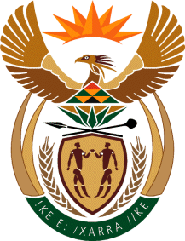
MINISTRY
SPORT AND RECREATION
REPUBLIC OF SOUTH AFRICA

Department of Sport and Recreation l Private Bag X896 l PRETORIA l 0001 l Regent Place l 66 Queen Street l Pretoria l 0001 l +27 (0)12 304 5158 l Fax: +27 (0)12 323 8426
Private Bag X9149 l Cape Town l 8000 l 2nd Floor Parliament Building l 120 Plain Street l CAPE TOWN l Tel: +27 21 469 5705 l Fax: +27 21 465 4402
www.srsa.gov.za
_____________________________________________________________________

NATIONAL ASSEMBLY

WRITTEN REPLY

QUESTION PAPER: No. 25 of 07 AUGUST 2017

DATE OF REPLY: 28 AUGUST 2017

2076. Mr P G Moteka (EFF) asked the Minister of Sport and Recreation:
Whether (a) his department and/or (b) any entities reporting to him are funding, including by way of discretionary funding, any institution of research and development (i) domestically and/or (ii) internationally; if so, (aa)(aaa) what are the names of the specified institutions and (bbb) what are their functions, (bb) from what date has his department or any entity reporting to him been funding them and (cc) what amount has his department contributed towards such funding? NW2298E
______________________________________________________________________
The Minister of Sport and Recreation
REPLY:

(a) and (b) (i) and (ii) The Department of Sport and Recreation South Africa and the entities reporting to the Executive Authority of the Department are not funding any institution of research and development, whether domestically and/or internationally, including by way of discretionary funding.

Thus, (aa) (aaa) and (bbb), (bb) and (cc) fall away.

