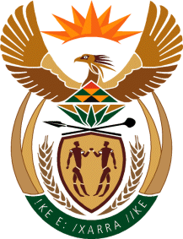

THE PRESIDENCY

REPUBLIC OF SOUTH AFRICA
Private Bag X1000, Pretoria, 0001

NATIONAL ASSEMBLY

QUESTIONS FOR WRITTEN REPLY
DATE OF PUBLICATION: 26 MAY 2023
QUESTION NUMBER: 2074(NW2346E)

2074. Mr E M Buthelezi (IFP) to ask the Minister in The Presidency for Electricity:
With reference to his submission during the meeting of the Standing Committee on Public Accounts on 17 May 2023, and in light of the fact that the failure of Eskom is visible through high levels of load shedding which are predicted to cost the economy 0,2 percentage points growth and add almost 0,5 percentage points to inflation this year, what has he done and/or initiated to ensure that those who engage in so-called naughty activities are brought to book?
REPLY
An Energy Safety and Security Priority Committee was established to address ESKOM-related crime on an inter-departmental, multi-disciplinary basis to address the objectives of Work Stream Six of the National Energy Crisis Committee (NECOM).

A total of 1952 Eskom-related cases were reported to the SA Police Service between 1 April 2022 and 29 May 2023, with 1405 cases still under investigation, and 126 arrests have been made.

Whilst much remains, these interventions are beginning to turn the situation around, and there are indications that operational measures implemented have clearly disrupted the activities of criminal syndicates.

