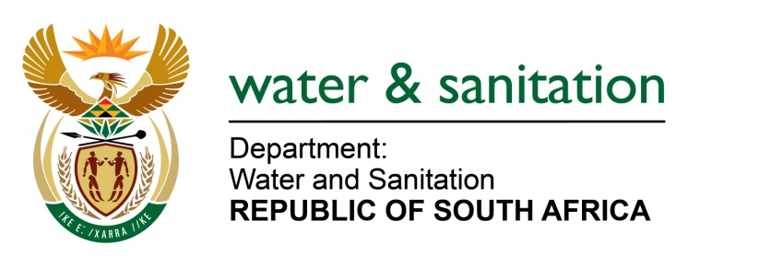

NATIONAL ASSEMBLY

FOR WRITTEN REPLY

QUESTION NO 2072

DATE OF PUBLICATION IN INTERNAL QUESTION PAPER: 27 May 2022
(INTERNAL QUESTION PAPER NO. 20)

2072. Mrs S M Mokgotho (EFF) to ask the Minister of Water and Sanitation:
What contingency plans have been put in place by his department to alleviate the challenge of water shortages in the Nelson Mandela Metropolitan Municipality where residents have been informed to use water sparingly?
NW2473E
---00O00---
MINISTER OF WATER AND SANITATION

My department is working closely with Nelson Mandela Bay Municipality (NMBM) and other affected and interested stakeholders to manage resources in the Algoa Water Supply System (AWSS). Monthly water use monitoring meetings are held to ensure that all users adhere to the restrictions imposed by my department.

The Department of Water and Sanitation (DWS) has developed a model to determine the percentage water restrictions that must be implemented to try and ensure that NMBM as well as the whole Algoa water supply system which includes Koukamma LM, Kouga LM as well as the Gamtoos Irrigation Board does not run out of water. This model is run on an annual basis to determine the domestic as well as the irrigation restrictions that must be implemented to ensure that the whole Algoa system does not reach day zero.

Restrictions were set at 40% of the water resources from the Western side of NMBM. The NMBM could not bring down their water use to the total restricted water use of 222Ml/day. The municipality could only reduce water use to 280 to 290Ml/day despite implementing several projects such as awareness campaigns, leak repairs, pressure management, increase in water tariffs, installation of water use restrictors to reduce the water use.

Interventions already being implemented include the following:
- The DWS previously provided drought funding to the metro to increase the capacity of the Nooitgedacht WTW (Phase 2) to supply more water from the Fish-Sundays River water supply system.
- The DWS further funded the Nooitgedacht Coega Low Level Phase 3 scheme which entailed the construction of a 45Ml/day balancing reservoir, an additional section to Water Treatment Plant of 70Ml/day to augment the current water supply from 140Ml/day to 210Ml/day. This project reached practical completion at the end of March 2022, which means that an additional 70Ml/day can be supplied to NMBM.
- Support to the NMBM to apply for drought funding to COGTA to augment the pumping capacity of the Motherwell and Stanford Road pumpstations and pump additional water to the Western side. COGTA has allocated R58 million drought funding towards this project and the DWS is part of the implementation team
- The DWS has allocated funding since 2019 towards the development of groundwater in the Kouga Local Municipality to reduce the water requirements of Kouga LM from the NMBM supply dams

The DWS is engaging the NMBM, GOGTA and National Treasury to discuss other possible solutions to ensure that the Western side of NMBM does not run out of water. One of the solutions under consideration is to pump more water from the Eastern side (where unrestricted water is available) to the Western side of the Metro.

Discussions have also been held with the Strategic Water Partner’s network to establish a Nelson Mandela Bay / Gqberha Water Partnership. This entails possible funding from the Private Sector to assist with interventions such leak repairs, water demand management as well as appointing experts to assist with the management of the water crisis. This will be managed by the Strategic Water Partner’s network in collaboration with NMBM and the NMB Business Forum.

Be assured that my department takes the current situation in NMBM serious and will assist the Metro to try and ensure that there will be water supply to the customers.

---00O00---

