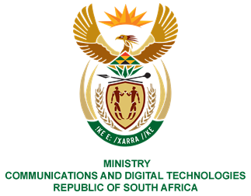

Private Bag X860, Pretoria, 0001, Tel: +27 12 427 8270 Fax: +27 12 427 8115
Private Bag X 9151, Cape Town, 8000 Tel: +27 21 469 5223 Fax: +27 21 462 1646
URL: http://www.dcdt.gov.za

ORAL REPLY 08 September 2021

(204). Mr Z N Mbhele (DA) to ask the Minister of Communications and Digital Technologies:
Given the crucial importance of private sector players in the communications and digital technologies arena with regard to their expertise, resources and assets, what steps has she taken or does she plan to take towards cultivating value-creating and synergistic public-private partnerships that will contribute to the imperative of advancing the Fourth Industrial Revolution and narrowing the digital divide in the Republic? NO2350E

REPLY
We believe in the founding tenets of this country of a social compact between government, business, labour and the value that cooperation and collaboration with other stakeholders adds to the reach and depth of any programme.

