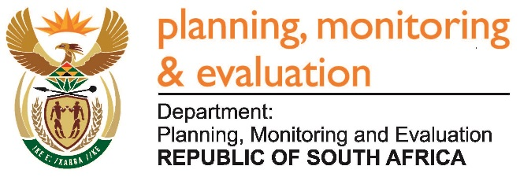
Private Bag X944, PRETORIA, 0001. Union Buildings East Wing, Government Avenue, PRETORIA
Tel: 012 312 0307. www.dpme.gov.za
2071. Ms M O Mokause (EFF) to ask the Minister in The Presidency:
Whether (a) his Office and/or (b) any entities reporting to him are funding, including by way of discretionary funding, any institution of research and development (i) domestically and/or (ii) internationally; if so, (aa)(aaa) what are the names of the specified institutions and (bbb) what are their functions, (bb) from what date has his Office or any entity reporting to him been funding them and (cc) what amount has his Office contributed towards such funding? NW2293E
REPLY:
The Department of Planning Monitoring and Evaluation does not fund institutions of research and development.
However, Statistics South Africa (Stats SA), has from 2015 up to date collaborated with the University of Stellenbosch, University of the Witwatersrand, University of Cape Town, University of Kwazulu Natal, Population Association of Southern Africa (PASA), South African Statistical Association (SASA), and University of Pretoria.
The purpose of the collaboration has been capacity building in use of statistics, promote collaboration among academia to build research and analytical skills capacity, conduct basic and operational research in the fields of regional and urban spatial development analysis, planning, policy formulation, and management and building capacity within the public and private sectors in the same fields. A research centre has been created where each year we send no less than 12 senior officials to study and create an interface between statistics and planning, which is sorely needed. The total amount contributed is R12 million.
The National Youth Development Agency (NYDA) has in collaboration with the University of Johannesburg established the Youth Development Institute of South Africa (YDSA). The function of which is to conduct youth development research, develop youth development programs and projects, manage and disseminate youth development knowledge, as well as lobbying and advocacy.
From 2014/2015 financial year up to 2016/2017 financial year the NYDA contributed R5.3 million.

