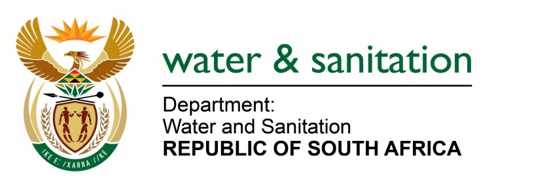

NATIONAL ASSEMBLY

FOR WRITTEN REPLY

QUESTION NO 2070

DATE OF PUBLICATION IN INTERNAL QUESTION PAPER: 27 MAY 2022
(INTERNAL QUESTION PAPER NO. 20)

2070. Mrs S M Mokgotho (EFF) to ask the Minister of Water and Sanitation:
By what date does he envisage villagers around Giyani in Limpopo will receive water from the Giyani reservoir, which has been empty since 2000?
NW2471E

---00O00-

MINISTER OF WATER AND SANITATION

The Giyani Water Treatment Works pumps potable water to the two main reservoirs which are the Low-lift and High-lift reservoirs on top of Mangombe mountain on a daily basis. The High-lift Reservoir pumps water to 3 pipelines F (South), F (North) and C. The Low-lift Reservoir pumps water to 3 pipelines B, E and D. The reservoirs pump water to 55 villages including Giyani Town in line with the rationing program in place.

---00O00---

