NATIONAL ASSEMBLY
36/1/4/1(201900035)

FOR WRITTEN REPLY QUESTION 207

DATE OF PUBLICATION IN INTERNAL QUESTION PAPER: 15 FEBRUARY 2019 (INTERNAL QUESTION PAPER NO 2-2019)

207. Mr Z N Mbele (DA) to ask the Minister of Police:

Whether, with reference to the legal opinion obtained by the SA Police Service (SAPS), as presented to the Portfolio Committee on Police (details furnished) on 21 August 2018, he and the SAPS top management has found that the specified provisions also apply to the operation of closed-circuit television (CCTV) cameras; if not, why not; if so, how does he and the SAPS reconcile their finding or position in respect of the legal opinion with the current operation of CCTV cameras at police stations?
NW217E
REPLY:

No, in terms of Section 4(1) of the Regulation of Interception of Communications and Communication-Related Information Act, 2002 (Act No. 70 of 2002), (hereinafter referred to as the Act) any person, other than a law enforcement officer, may intercept any communication if he or she is party to the communication, unless such communication is intercepted by such person for purposes of committing an offence. In terms of Section 4(2) of the Act, any law enforcement officer may intercept any communication if he or she is:
- a party to the communication; and
- satisfied that there are reasonable grounds to believe that the interception of a communication of another party to the communication is necessary, on grounds referred to in Section 16(5)(a) (relating to serious offences), unless such communication is intercepted by such law enforcement officer, for the purposes of committing an offence.

In terms of Section 1 of the Act, “intercept” is defined to mean the aural or other acquisition of the contents of any communication, through the use of any means, including; an interception device, so as to make some or all of the contents of a communication available to a person other than the sender or recipient or intended recipient of that communication and includes, the:
- monitoring of any such communication by means of a monitoring device;

2

- viewing, examination or inspection of the contents of any indirect communication; and
- diversion of any indirect communication from its intended destination to any other destination and “interception” has a corresponding meaning.

A “communication” is defined in Section 1 of the Act, to include both a direct communication and an indirect communication.
A “direct communication” is defined to mean an:
- oral communication, other than an indirect communication, between two or more persons, which occurs in the immediate presence of all the persons participating in that communication; or
- utterance by a person who is participating in an indirect communication, if the utterance is audible to another person who, at the time that the indirect communication occurs, is in the immediate presence of the person participating in the indirect communication.

An “indirect communication” is defined as the transfer of information, including; a message or any part of a message, whether it is:
- in the form of:
  - speech, music or other sounds;
  - data;
  - text;
  - visual images, whether animated or not;
  - signals; or
  - radio frequency spectrum; or
- in any other form or in any combination of forms, that is transmitted in whole or in part, by means of a postal service or an electronic communication system1. (Own underlining).

In light of the above, the Act prohibits the interception of audio communications (in other words the interception of what is spoken). Visual images, such as those recorded by closed circuit television, are not transmitted by means of the postal

' The definition of indirect communication in the Act was amended by the Electronic Communications Act No. 36 of 2005”. The definition of telecommunication system was replaced by “electronic communication system”. (Government Gazette No. 28743 of 18 April 2006).

3

services or an electronic communications system. The actions, gestures or activities of a person, without sound, fall outside the definition of a “direct communication”.

The Act aims to protect the privacy of communications, in general. It is submitted that the prohibition of the Act, does not apply in circumstances, where a person makes an oral communication in circumstances, where there is no reasonable expectation of privacy (for instance in a police station).

In line with the Act, closed circuit television at police stations does not record audio communications but only activities that take place. Body-worn cameras, which have the ability to record activities and audio communications may, however, contravene Section 4(1)(a) of the Act. (Own underlining).

Response to question 207 recommended/

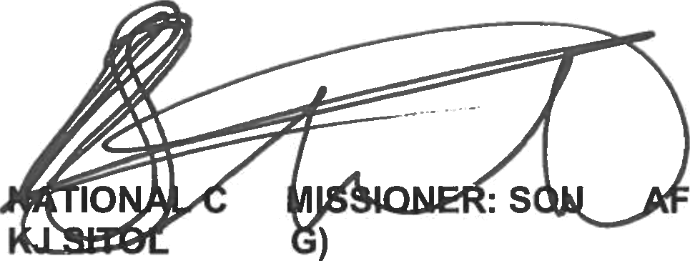GENERAL RICAN POLICE SERVICE
OM
E (SOE
TH

Response to question 207 approved/not approved

MINISTER OF POLICE
BH CELE, MP

Date:

