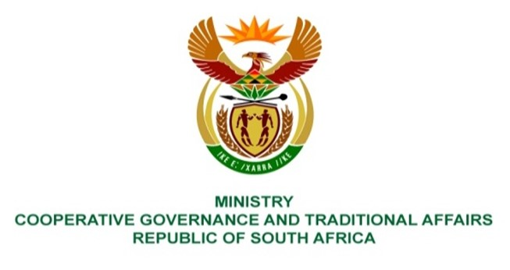

NATIONAL ASSEMBLY
QUESTIONS FOR WRITTEN REPLY

QUESTION NUMBER 2063
DATE OF PUBLICATION: 26 MAY 2023

2063. Mr J F Smalle (DA) to ask the Minister of Cooperative Governance and Traditional Affairs:

(1) What is the (a) total number of fire stations in each province, (b) current number of (i) bakkies, (ii) trucks and (iii) other specified vehicles at each fire station and (c) respective reaction time for each of the stations to attend to an emergency;

(2) whether any of the municipalities entered into memoranda of understanding with other municipalities and/or provinces where services are not provided; if not, what is the position in this regard; if so, what are the relevant details? NW2332E

REPLY:
Figure 1 below provides details of the municipalities across the country regarding (1) What is the (a) total number of fire stations in each province, (b) current number of (i) bakkies, (ii) trucks and (iii) other specified vehicles at each fire station and (c) respective reaction time for each of the stations to attend to an emergency.

NAME OF PROVINCE | a) TOTAL NUMBER OF FIRE STATIONS IN EACH PROVINCE | (b) CURRENT NUMBER FIRE APPLIANCES (in all categories) | MEMORANDA OF UNDERSTANDING/ MUTUAL AID AGREEMENT
Western Cape | 95 (ninety five) | 657 (six hundred and fifty seven) | In terms of Section 12 of the Fire Brigade Services act 99 of 1987,and contextualizing of front-end partnerships, provinces, districts/metro and local municipalities maintains a formal Mutual Aid Agreement. Coordination of assistance and resources are performed by the respective District Municipalities in terms of the Section 84 (1) (j) (i) of the Municipal Structures act 117 of 1998. All municipal as well as Designated fire services have access to said agreement.
Free State | 20 (twenty) | 41 (forty one)
Gauteng | 93 (ninety three) | 204 (two hundred and four)
Eastern Cape | 33 | 114
KwaZulu Natal | 61 | 145
North West | 21 | 83
Limpopo | 27 | 86
Mpumalanga | 17 | 69
Northern Cape | 9 | 32
End

