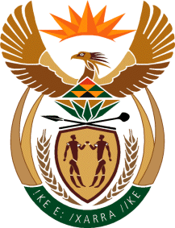

THE PRESIDENCY

REPUBLIC OF SOUTH AFRICA
Private Bag X1000, Pretoria, 0001

NATIONAL ASSEMBLY

QUESTIONS FOR WRITTEN REPLY
DATE OF PUBLICATION: 26 MAY 2023
QUESTION NUMBER: 2062 (NW2331E)

2062. Mr J F Smalle (DA) to ask the Minister in The Presidency for Electricity:
Whether he has had engagements with each province regarding plans to mitigate the impact of a total blackout should load shedding be implemented beyond stage 8; if not, why not; if so, (a) which provinces have a plan in place and (b) what is the current status of each plan?
REPLY

The Ministry had conversations with the Western Cape, Eastern Cape and Gauteng Provincial governments, the Cape Town, Buffalo City, Johannesburg and Nelson Mandela Bay Metropolitan Municipality regarding their individual energy needs. In addition, the Ministry is scheduling fresh visits to each of the 9 Provincial Executive Councils, the leadership of Metropolitan Municipality and secondary Cities during June/July 2023 on the Energy Action Plan (EAP) and the interventions being undertaken to improve generation and reduce demand. These conversations will include the impact of revenue for municipalities and challenges regarding wheeling frameworks and feeding tariffs.

