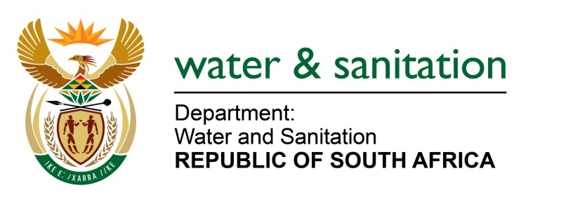

NATIONAL ASSEMBLY

FOR WRITTEN REPLY

QUESTION NO 2060

DATE OF PUBLICATION IN INTERNAL QUESTION PAPER: 07 AUGUST 2017
(INTERNAL QUESTION PAPER NO. 25)
2060. Inkosi R N Cebekhulu (IFP) to ask the Minister of Water and Sanitation:
What is her department doing to stop the (a) contamination of our water supply such as rivers by municipalities and (b) flow of old motor oil from the notorious pavement mechanics into our water supply? NW2281E

---00O00---
REPLY:

(a) After communicating the Green Drop Progress Report Results of 2014, my Department prioritized 260 systems that are put under regulatory surveillance to monitor progress and reduction of risks identified in the report. Our Compliance team has audited 17 treatment works during this year (2017). Treatment works that do not comply are dealt with through Administrative Enforcement. This year, the Department of Water and Sanitation as well as the Department of Environmental Affairs will be conducting joint operations for certain priority treatment works.
(b) This specific form of pollution falls under the mandate of the National Department of Water and Sanitation, the Provincial Department of Environment (Waste and Pollution) as well as Local Government (Pollution and Storm Water Management). The Department's Directorate: Water Services Sector Development regularly updates model by-laws and shared with the Water Services Authorities to fine tune according to their municipal set up and industries/activities applicable in their area of operation and promulgated by respective council for implementation. Due to possible overlapping of mandates, my Department has not to date had an operation/project to raise awareness to address this matter. It will be tabled at Outcome 10 working group IV where the relevant parties can deliberate and bring a pragmatic plan of action to the table.
---00O00---

