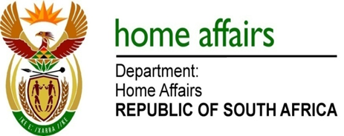

NATIONAL ASSEMBLY

QUESTION FOR WRITTEN REPLY

QUESTION NO. 2058

DATE OF PUBLICATION: Friday, 23 September 2016

INTERNAL QUESTION PAPER 29 OF 2016

2058. Mr H B Groenewald (DA) to ask the Minister of Home Affairs:

(1) Whether each Head of Department (HOD) of his department signed a performance agreement since their appointment; if not, (a) what is the total number of HODs who have not signed performance agreements, (b) what is the reason in each case, (c) what action has he taken to rectify the situation and (d) what consequences will the specified HOD face for failing to sign the performance agreements; if so, (i) when was the last performance assessment of each HOD conducted and (ii) what were the results in each case;
(2) whether any of the HODs who failed to sign a performance agreement received a performance bonus since their appointment; if not, what is the position in this regard; if so, (a) at what rate and (b) what criteria were used to determine the specified rate;
(3) whether any of the HODs who signed a performance agreement received a performance bonus since their appointment; if so, (a) at what rate and (b) what criteria were used to determine the rate? NW2369E
REPLY:

(1)(a-d) The HOD (Director-General) was appointed on a 5 year contract with effect from 1 April 2010 to 31 March 2015 and at the end of his contract the Minister took a decision to reappoint the Director-General (DG) for another 5 years. In terms of the SMS Handbook HOD’s / DG’s are required to sign an annual performance based agreement for the performance cycle (financial year) 1 April – 31 March. To date, DG has complied with this requirement. DG’s last performance assessment was for the financial cycle 2014/15 and was conducted and finalized on 02 December 2015.

- Not applicable.

(3)(a-b) DG (HOD) received a performance bonus for the financial year 1 April 2010 – 31 March 2011. DG received a category B outcome at a rate of 8% which was in line with the department’s performance in accordance with the SMS Handbook.

