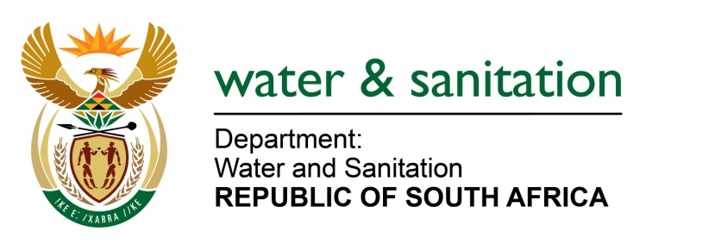

NATIONAL ASSEMBLY

FOR WRITTEN REPLY

QUESTION NO 2057

DATE OF PUBLICATION IN INTERNAL QUESTION PAPER: 27 AUGUST 2021
(INTERNAL QUESTION PAPER NO. 19)

2057. Ms S A Buthelezi (IFP) to ask the Minister of Water and Sanitation:

What are the relevant facts that has been recorded by her department regarding the effects of the dry winter season on water reserves in all affected provinces?

NW2294E
---00O00---
MINISTER OF WATER AND SANITATION

South Africa receives both summer and winter rainfall, with most Provinces falling within the summer rainfall area; whereas the Western Cape Province receives its rainfall mainly in winter. As a result, annual water allocation decisions for the summer rainfall areas are made in May or June when most of the summer rainfall is believed to have been harvested. On the other hand, the decision date for the winter rainfall areas is November.

The water reserves in most Provinces have been generally sufficient due to good rains received during the past summer rainfall season. The state of water storage in dams as at 30 August 2021 per Province is indicated in the table below:

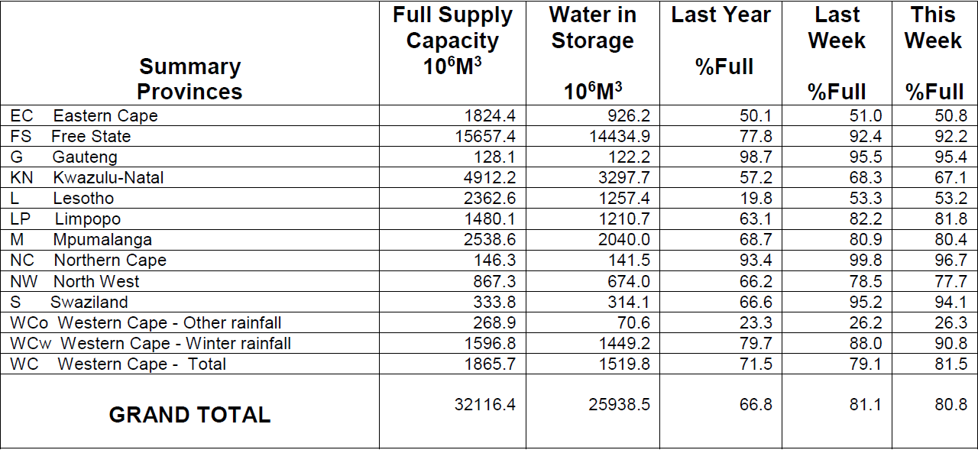

Water availability and supply situation is determined by undertaking an Annual Operating Analysis (AOA) of the relevant water supply systems in the Provinces. The AOA determines the amount of water that can be supplied sustainably and equitably over the coming year considering the amount of water in storage at the decision date of the system. Water restrictions are implemented in cases of inadequate water availability.

The provinces with relatively less water availability, as indicated by low Dam levels, are located in the Eastern Cape and parts of the Western Cape Provinces. Dam levels in the Western Cape winter rainfall area are generally good and still increasing given that the Province is still in its rainfall season.

The main two water supply systems in the Eastern Cape experiencing water shortages are the Algoa and Amathole Water Supply Systems (WSS). The Algoa WSS supplies water to the Nelson Mandela Bay Municipal Metro (NMBMM), Kouga Local Municipality and the irrigation sector. On the other hand, Amathole WSS supplies the Buffalo City Local Municipality and Amatola Water Board in East London and surrounding areas; as well as the irrigation sector.

On river systems that have been found to have inadequate water availability for the season, water restrictions are proclaimed in the government gazette to curb water abstractions in order to prolong supplies, especially for essential use. The Provinces with water restrictions on a number of systems/dams are listed below as:

Eastern Cape Province
The Algoa Water Supply System, which supplies the Nelson Mandela Bay Metro area, comprises of 5 Dams and is also augmented by the Orange-Fish-Sundays transfer scheme from the Orange River System in the Free State. There are currently restrictions imposed at 80% on irrigation supply and an overall 30% on the domestic sector. Specific restrictions for the different dams are indicated in Table 2.

Dam | Net Full Supply Capacity (Million m³) | Storage Level (%) – 01 Jun 2021 (Decision Date) | Storage Level (%) – 30 Aug 2021 | % Restrictions
Churchill | 35.24 | 23.07 | 19.55 | 50% Domestic & 80% Irrigation
Impofu | 105.76 | 15.04 | 16.99
Kouga | 125.91 | 4.22 | 5.44 | 70% Domestic & 80% Irrigation
Loerie | 3.03 | 37.16 | 32.8
Groendal | 11.64 | 26.64 | 21.81 | 80% Irrigation
Total System | 281.6 | 11.92 | 12.51 | 30% Domestic and 80% Irrigation

Note: A supply of 58 million m³/a from the Orange-Fish-Sundays transfer scheme to the NMBMM
is not restricted

The Amathole Water Supply System, which supplies the Buffalo City area comprises of 6 Dams as detailed in table 3 below – 10% Restrictions are required on the domestic water supply and 30% on irrigation.

Dam | Net Full Supply Capacity (Million m³) | Storage Level (%) – 01 Jun 2021 (Decision Date) | Storage Level (%) – 30 Aug 2021 | % Restrictions
Rooikrantz | 4.79 | 97.14 | 77.59 | 10% on Domestic & 30% on irrigation
Laing | 18.90 | 99.57 | 100.65
Bridle Drift | 97.92 | 26.59 | 21.15
Wriggleswade | 91.47 | 19.06 | 14.88
Nahoon | 19.26 | 42.00 | 28.86
Gubu | 8.52 | 85.76 | 79.36
Total System | 240.88 | 34.19 | 28.81

Stand-alone Dams in Eastern Cape Province that are experiencing water shortage and requiring restriction rules for the season are listed in Table 4 below.

Dam | Net Full Supply Capacity (Million m³) | Storage Level (%) – 01 Jun 2021 (Decision Date) | Storage Level (%) – 30 Aug 2021 | % Restrictions
Nqweba | 44.7 | 8.0 | 6.7 | 20% domestic
Howiesonspoort and Settlers Dam | 6.4 | Not known - no information received from the municipality |  | 20% domestic & 70% irrigation
Sandile | 29.7 | 56.0 | 50.7 | 30% irrigation
Xilinxa and Gcuwa | 14.2 | 20.4 | 7 | 20% domestic
Kliplaat | 57.1 | 26.9 | 24.3 | 30% irrigation
Mhlanga | 1.6 | 13.2 | 35.1 | 10% domestic

Western Cape Province
Stand-alone Dams in Western Cape Province that are experiencing water shortages and requiring restriction rules for the season are listed in Table 5 below.

Dam | Net Full Supply Capacity (Million m³) | Storage level at decision date 1 June 2021 | Storage Level (%) – 30 Aug 2021 | Restrictions Required at Decision Date
Gamka | 1.82 | 45.1 | 32.62 | 10% domestic
Oukloof | 4.19 | 0.0 | 0.00 | 90% irrigation
Karee | 0.95 | 14.9 | 21.00 | 50% domestic

Mpumalanga Province
Stand-alone Dams in Mpumalanga Province that are experiencing water shortage and requiring restriction rules for the season are listed in Table 6 below.

Dam | Net Full Supply Capacity (Million m³) | % Storage decision date - 1 May 2021 | Storage Level (%) – 30 Aug 2021 | Restrictions Required at Decision Date
Mkhombo | 204.6 | 10 | 7.6 | 10% domestic, 40% irrigation
Rust de Winter | 28.2 | 100 | 99.65 | 10% domestic, 40% irrigation
Ohrigstad | 13.5 | 100 | 57.6 | 10% domestic and irrigation

Limpopo Province
Stand-alone Dams in Limpopo Province that are experiencing water shortage and requiring restriction rules for the season are listed in Table 7 below.

Table 7: Stand-alone Dams in Limpopo Province
Dam | Net Full Supply Capacity (Million m³) | % Storage decision date 1 May 2021 | Storage Level (%) – 30 Aug 2021 | Restrictions Required at Decision Date
Middle Letaba | 171.9 | 11 | 7.79 | 35% domestic, 70% irrigation
Nsami | 21.9 | 90.5 | 71.46 | 35% domestic, 70% irrigation

---00O00--

