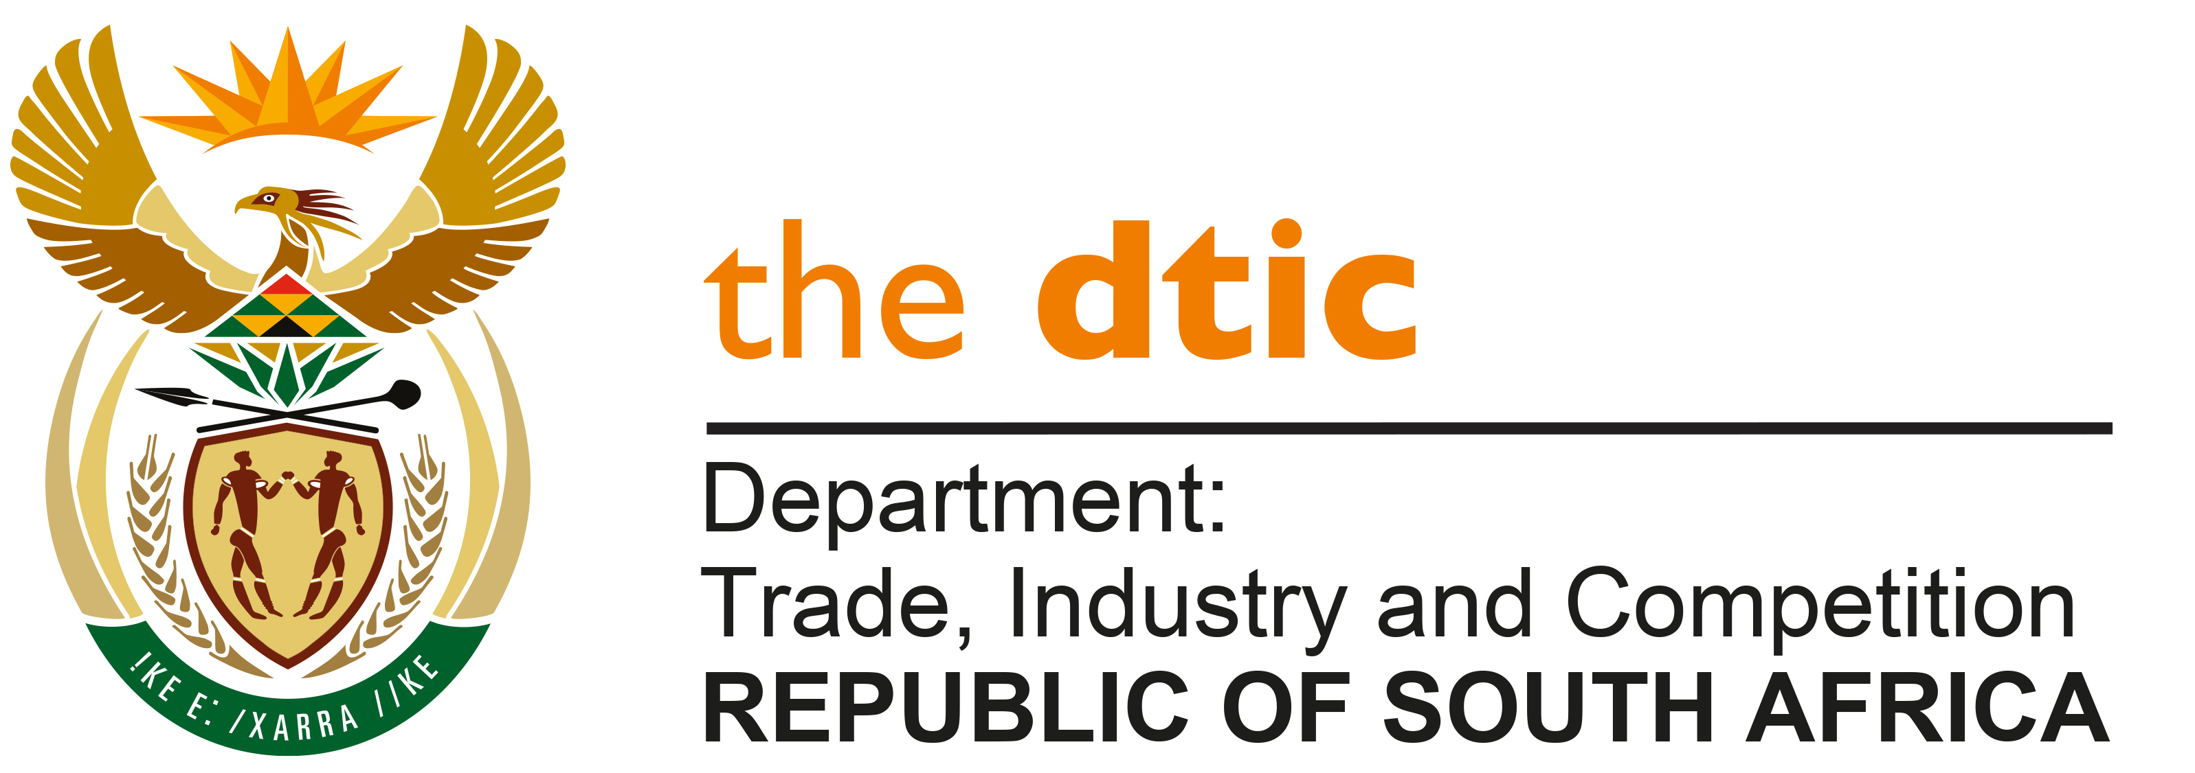

THE NATIONAL ASSEMBLY

QUESTION FOR WRITTEN REPLY

QUESTION NO. 2050

DATE PUBLISHED: 27 AUGUST 2021

Inkosi R N Cebekhulu (IFP) to ask the Minister of Trade, Industry and Competition:

What are his department’s existing and planned efforts to (a) boost exports, promote investment and create high-value, high-paying jobs in order to build back from the effects of COVID-19 and (b) ensure every part of the Republic benefits from our trade strategies? [NW2287E]

REPLY:

The Economic Reconstruction and Recovery Plan, to which the DTIC contributed, sets out the overall approach by Government to boost exports, promote investment and create decent work opportunities as part of the response to Covid-19.

Within that framework, the Annual Performance Plan of the Department tabled in Parliament this year sets out a more detailed set of actions covering trade, investment and industrial development. This was further complemented by the package of measures announced recently to address the damage caused by the unrest in parts of KZN and Gauteng in early July 2021.

The work programme cover inter alia the following
- Progressing the work on the African Continental Free Trade Agreement, specifically focused on completion of a set target on rules of origin on industrial products; and conclusion of discussions on services.
- Implementing a number of sector growth plans, covering core industrial activities (steel and autos), food security (poultry and sugar) and consumer goods (clothing & textiles and furniture).
- Expanding levels of private sector investment in the economy to boost economic output, including through support to firms in implementation of pledges made at South African Investment Conferences.
- Improving the business environment through providing an efficient company registration service and addressing unnecessary regulatory requirements applicable in DTIC public entities;
- Promoting opportunities for a larger number of South Africans through competition and empowerment policies, which include the work of development finance institutions; and
- Supporting equitable development in different parts of the country through a new focus on district development and compiling economic information on each district municipality.

-END-

