36/1/4/1(2019)
NATIONAL ASSEMBLY

FOR WRITTEN REPLY QUESTION 205
DATE OF PUBLICATION IN INTERNAL QUESTION PAPER: 15 FEBRUARY 2019 (INTERNAL QUESTION PAPER NO 2-2019)

205. Ms D Kohler (DA) to ask the Minister of Police:

(a) What is the total amount of Mr Robert McBride’s legal costs which his department was ordered to pay in terms of the ruling in the Constitutional Court case of McBride v Minister of Police and Another (CCT255/15) [2016] and (b) on what date did his department pay Mr Robert McBride the costs as ordered by the court?
NW215E
REPLY:

I have provided my reasons to the Police Portfolio Committee on the 18t * of February 2019.

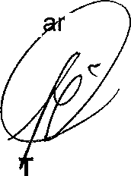
Kind reg ds,

MINIS ER OF POLICE
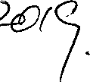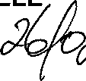B.H CELE DATE:

