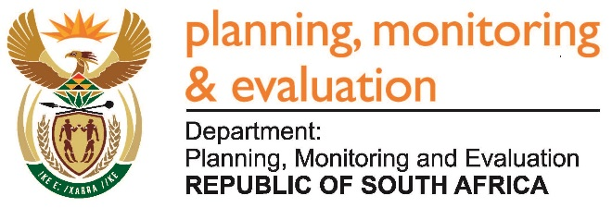
Private Bag X944, PRETORIA, 0001. Union Buildings East Wing, Government Avenue, PRETORIA
Tel: 012 312 0307. www.dpme.gov.za
______________________
NATIONAL ASSEMBLY
QUESTIONS FOR WRITTEN REPLY

2045. Mr S Esau (DA) to ask the Minister in The Presidency:

What formal qualifications does each of his department’s (a)(i) Chief Financial Officers and/or (ii) acting Chief Financial Officers and (b)(i) Directors-General and/or (ii) acting Directors-General possess? NW2356E

Reply:

The CFO of the Department of Planning, Monitoring and Evaluation holds a BA (political Science) and BA Honours (International Relations) degrees from the University of Pretoria (UP); B. Com (Business Management and Economics) from University of South Africa (UNISA); Microsoft Certified Systems Engineer (MCSE); Currently studying MPhil Development Policy and Practice at the University of Cape Town (UCT).

The Acting Director General holds: a Bachelor & Honours Degrees in Economics and Politics from the University of Cape Town (UCT); Masters in Development Economics from the University of East Anglia (UK); Various certificates, including an Executive Management certificate, as well as a certificate in Infrastructure Development from Harvard University’s J F Kennedy School of Government in the US.

The Statistician General holds: a Bachelor of Arts: Double Major in Statistics and Economics from the University of Lesotho; Post-graduate Diploma in Demography - United Nations Regional Institute for Population Studies (RIPS); University of Ghana. The University of Stellenbosch conferred on Pali Lehohla an Honorary Doctorate for his extensive contribution in global affairs. v

Chief Financial Officer holds a Baccalaureus Technologiae: Business Administration; Tshwane University of Technology; National Diploma in Cost and Management Accounting; Witwatersrand Technikon (University of Johannesburg).

