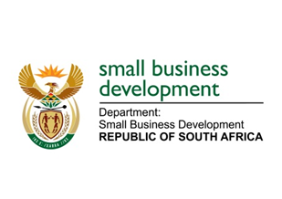

NATIONAL ASSEMBLY
QUESTION FOR WRITTEN REPLY
DUE TO PARLIAMENT: FRIDAY, 11 SEPTEMBER 2020

2044. Mr Z N Mbhele (DA) to ask the Minister of Small Business Development:
(1) What number of small and medium enterprises (SMEs) have received government-guaranteed loans since the declaration of a state of national disaster;
(2) whether her department provided inputs to the National Treasury on the planning and design of the Loan Guarantee Scheme for SMEs in order to ensure that the interest and unique needs and/or circumstances of (a) SMEs and (b) sole proprietors were substantively taken into account; if not, why not; if so, what are the relevant details?NW2606E

REPLY:

- The Department of Small Business Development (DSBD) is not responsible for the National Credit Guarantee Scheme as it is being implemented by National Treasury with the Reserve bank through the Commercial Banks.

- The Department of Small Business Development (DSBD) was not requested to provide inputs in the development of the Loan Guarantee Scheme. However, since it became apparent that the National Credit Guarantee Scheme is not succeeding to fund mainly black owned small businesses that are continuously being rejected despite the relaxation of the funding criterion, the Department together with the Small Enterprise Finance Agency (sefa), have tabled a proposal to National Treasury to accommodate Khula Credit Guarantee (sefa subsidiary) to participate in the National Credit Guarantee Scheme in address the apparent market failure. The proposal is awaiting the decision of the Minister of Finance.

