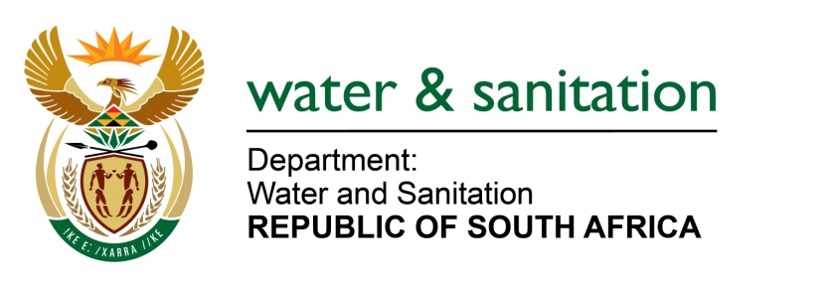

NATIONAL ASSEMBLY

FOR WRITTEN REPLY

QUESTION NO 2043

DATE OF PUBLICATION IN INTERNAL QUESTION PAPER: 23 SEPTEMBER 2016
(INTERNAL QUESTION PAPER NO. 29)

2043. Dr M J Figg (DA) to ask the Minister of Water and Sanitation:

What formal qualifications does each of her department’s (a)(i) Chief Financial Officers and/or (ii) acting Chief Financial Officers and (b)(i) Directors-General and/or (ii) acting Directors-General possess? NW2354E
---00O00---

REPLY:
(a)(i) Mr SV Mkhize, the Chief Financial Officer (Main Account), is in possession of a National Diploma Accountancy, Advanced Project Management Programme, and a Master Degree in Business Administration.
Mr M Mofokeng, the Chief Financial Officer (Water Trading Account), is in possession of a National Diploma Accountancy, and a B Tech in Business Administration.
(a)(ii) Ms MS Manukuza, the Acting Chief Financial Officer (Main Account), is a Chartered Accountant and is also in possession of a Bachelors of Commerce (Accounting), and an Honors in Bachelor of Accounting Sciences.
(b)(i) The post of Director-General is currently vacant.
(b)(ii) Mr SV Mkhize is currently acting as Director-General of Water and Sanitation, refer to (a)(i) above for qualifications.
---00O00---

