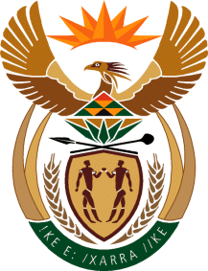

MINISTRY OF TOURISM

REPUBLIC OF SOUTH AFRICA

Private Bag X424, Pretoria, 0001, South Africa. Tel. (+27 12) 444 6780, Fax (+27 12) 444 7027

Private Bag X9154, Cape Town, 8000, South Africa. Tel. (+27 21) 469 5800, Fax: (+27 21) 465 3216

Ref: TM2/1/1/0

NATIONAL ASSEMBLY:

QUESTION FOR WRITTEN REPLY:
Question Number: 2040
Date of Publication: 23 September 2016
NA IQP Number: 29
Date of reply:

Ms J Edwards (DA) to ask the Minister of Tourism:

What formal qualifications does each of his department’s (a) (i) Chief Financial Officers and/or (ii) acting Chief Financial Officers and (b) (i) Directors-General and/or (ii) acting Directors-General possess? NW2351E

Reply:
a) (i) Chief Financial Officer
National Diploma: State Accounts and Finance
(ii) Acting Chief Financial Officers
Not applicable
(b)(i) Directors-General
Bachelor of Science Degree in Physics and Applied Physics
International Graduate Diploma in Environmental Management (Israel)
Postgraduate Diploma in Strategic Management and Corporate Governance
Graduate Diploma in Company Direction
(ii) Acting Directors-General
Not applicable

