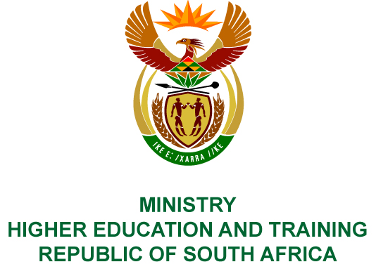
Private Bag X893, Pretoria, 0001, Tel (012) 312 5555, Fax (012) 323 5618
Private Bag X9192, Cape Town, 8000, Tel (021) 469 5150, Fax: (021) 465 7956
Memorandum from the Parliamentary Office
NATIONAL ASSEMBLY
FOR WRITTEN REPLY
QUESTION 204
DATE OF PUBLICATION OF INTERNAL QUESTION PAPER: 08/02/2018

(INTERNAL QUESTION PAPER NO 1 OF 2018)
Ms V Ketabahle (EFF) to ask the Minister of Higher Education and Training:
Did the National Institute for Humanities and Social Sciences use the services of a certain company (name furnished) on 6 July 2017; if not, what is the position in this regard; if so, (a) what (i) is the total number of persons who were transported, (ii) are the details of each person who was transported, (iii) is the total cost for each person who travelled, (iv) was the total cost of the trip, (b) was the service that was provided by the specified company the cheapest option, (c) did the spending comply with (i) the National Treasury’s cost cutting measures and (ii) the regulations of (aa) her department and (bb) the Auditor-General of South Africa and (d) who approved the (i) trip and (ii) payment?
NW212E

REPLY:
The National Institute for Humanities and Social Sciences (NIHSS) has provided the following responses to the questions posed.
The services of Exclusive Tours was used.
- (i) A total of 24 staff members were transported.
(ii) The names of the staff members are as follows:
Number | Name
 | Ntambudzeni Tshiswaise
 | Livhuwani Mavhunga
 | Musa Maphalakasi
 | Adelaide Kubeka
 | Kgomotso Ramushu
 | Ayanda Zwane
 | Ayanda Zondi
 | Idah Makukule
 | Elias Phaahla
 | Tumelo Mokoena
 | Sarah Mosoetsa
 | Nthabiseng Motsemme
 | Busi Pilane
 | Nicola Critchfield
 | Tlaleng Mofokeng
 | Cebile Jali
 | Tshiamo Molapisi
 | Tshiamo Rakau
 | Kambale Muhongya
 | Lebohang Magage
 | Papama Magqwashe
 | Tebogo Molaoa
 | Keketso Phakoe
 | Matlhogonolo Maselwanyane
(iii) The average cost per person was R 1 625.
(iv) The total cost of the trip was R39 000.
- It was the cheapest travel option.
- (i) The expenditure complied with the NIHSS’s policies. The NIHSS is neither a Department, nor a constitutional institution, nor a public entity listed in Schedule 2 or 3, and therefore the Public Finance Management Act is not applicable to the NIHSS.
(ii) (aa) Spending is managed by the NIHSS in terms of its policies.
(bb) The Auditor-General of South Africa audits the NIHSS in terms of Section 38 of the Higher Education Act and since its inception has received unqualified audit opinions.
- The Chief Executive Officer, Professor Sarah Mosoetsa, approved the trip and expenditure.

COMPILER DETAILS
NAME AND SURNAME: MS PEARL WHITTLE
CONTACT: 012 312 5248
RECOMMENDATION
It is recommended that the Minister signs Parliamentary Question 204.

MR GF QONDE
DIRECTOR–GENERAL: HIGHER EDUCATION AND TRAINING
DATE:

PARLIAMENTARY QUESTION 204 IS APPROVED / NOT APPROVED / AMENDED.
COMMENT/S

PROF HB MKHIZE, MP
MINISTER OF HIGHER EDUCATION AND TRAINING
DATE:

