___________________________________________________________________

NATIONAL ASSEMBLY

QUESTION FOR WRITTEN REPLY

QUESTION NUMBER: 2038
DATE OF PUBLICATION IN INTERNAL QUESTION PAPER: 26 MAY 2023
INTERNAL QUESTION PAPER NUMBER: 19 – 2023

2038. Ms A L A Abrahams (DA) to ask the Minister of Social Development:
What number of (a) persons and (b) households that receive a social grant have been linked to (i) permanent and/or (ii) temporary economic and employment opportunities through her department since 1 January 2019 in each province?
NW2306E
REPLY:

The department developed a framework for linking social grant beneficiaries to sustainable livelihoods and economic opportunities in provinces through sustainable livelihoods programmes.

- (i) (ii).The department has linked 49 449 persons that receive a social grant to economic and employment opportunities. The linking data is not disaggregated according to the permanent or temporary opportunities but only economic or sustainable livelihoods opportunities. Since 1 January 2019 the department of Social Development have managed to link 49 449 persons receiving social grants to Sustainable Livelihoods opportunities as follows:

PERSONS LINKED TO ECONOMIC OPPORTUNITIES
Province | Linked to economic opportunities | Type of linkages
Eastern Cape | 6 262 | Skills, employment, cooperatives
Free State | 2 348 | Skills, employment, cooperatives
Gauteng | 25 900 | Skills, employment, cooperatives
Kwa Zulu Natal | 976 | Skills, employment, cooperatives
Limpopo | 848 | Skills, employment, cooperatives
NDA | 2300 | Volunteerism
Mpumalanga | 18 | Skills, employment, cooperatives
Northern Cape | 848 | Skills, employment, cooperatives
North West | 329 | Skills, employment, cooperatives
Western Cape | 9620 | Skills, employment, cooperatives
Total | 49 449

- The department link persons and households that receive a social grant, to economic and sustainable livelihoods in all nine provinces. Since 1 January 2019 the department of social development and its entities have managed to link an average of 12 362 households to sustainable Livelihoods opportunities.

SASSA

(a) (i) and (ii)

SASSA has a target on its Annual Performance Plan to link beneficiaries to economic and developmental opportunities. Activities which support this target include sharing details of children who are in grade 12 and are benefiting from social grants with the National Student Financial Aid Scheme. This ensures that the children on the social grant system are first in line for financial aid, to enable them to study further. It is believed that education will enable these young people to break the cycle of inter-generational poverty and dependence on social grants.

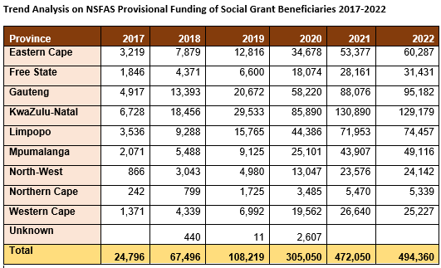

Another initiative which SASSA is engaged with is to collaborate with the Project Office in the Presidency which is responsible to implement the Presidential Youth Employment Programme. SASSA assisted in sending SMS notifications to all the young people aged 18 to 35 years who had applied for the social relief of distress grant of R350 to alert them of the youth.mobi website. This website contains information of multiple work opportunities in both the public and private sector, where young people can get information to follow up if they feel they are suited.

GENERAL

The Department and its Agencies (SASSA and NDA) with the support from FinMark Trust (FMT), an independent trust, are piloting the “Generating Better Livelihoods for Grant Recipients” project in line with the Department’s Framework on Linking Social Protection Beneficiaries to Sustainable Livelihoods Opportunities. The project aims to develop pathways for social grant recipients to attain sustainable livelihood opportunities through employment, skills development and/or entrepreneurship. The project’s primary target is child support grant; However, the support will not be limited to this target group. It will be extended to other household members including the beneficiaries of the Covid-19 SRD grant.

