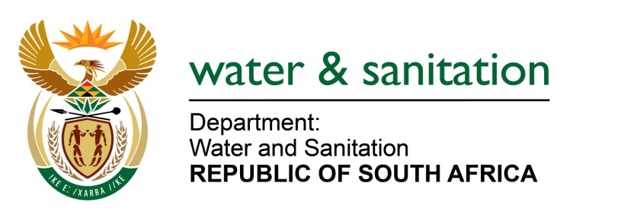

NATIONAL ASSEMBLY

FOR WRITTEN REPLY

QUESTION NO 2035

DATE OF PUBLICATION IN INTERNAL QUESTION PAPER: 30 JUNE 2017
(INTERNAL QUESTION PAPER NO. 24)
2035. Ms T E Baker (DA) to ask the Minister of Water and Sanitation:
(a) What is the name of each (i) water user association and (ii) irrigation board in each province that owes her department money, (b) what is the total amount that each (i) association and (ii) board owe, (c) for how long has each payment been in arrears and (d) what are the (i) names and (ii) locations of each affected water board in each case? NW2250E
---00O00---
REPLY:

Refer to Annexure A for the age analysis of the Water User Association and Irrigation Board in each province that owe my Department money.

---00O00---

