MEMORANDUM FROM THE PARLIAMENTARY OFFICE
NATIONAL ASSEMBLY
FOR WRITTEN REPLY
QUESTION 2029
DATE OF PUBLICATION OF INTERNAL QUESTION PAPER: 28/08/2020
INTERNAL QUESTION PAPER NO 34 OF 2020

Prof B Bozzoli (DA) to ask the Minister of Higher Education, Science and Technology:
(1) (a) Who is the information, communications and technology (ICT) service provider to the Department of Science and Innovation, (b) why is the specified department’s homepage of such poor quality and (c) why is it more offline than online;
(2) whether he will provide Prof B Bozzoli with a breakdown of the history of his department’s main ICT contractors and their service level agreements; if not, why not; if so, what are the relevant details?
NW2590E

REPLY:

- There is no one service provider contracted by the department for ICT services. Suppliers are contracted as an when required for goods and services through SITA and Supply Chain Management process.

- The Department of Science and Innovation (DSI) complies with the GCIS Policy Guidelines for South African Government websites. The guidelines require that all government websites look uniform and that webmasters follow best practices in terms of the website information architecture, that refers to composition of structure, functions and website navigation. The DSI website conforms, in that the home page can be differentiated from other pages in the website. It is organised, displays options and gives a clear overview of what information is available on the website.

The link to the guidelines are below: https://www.gcis.gov.za/sites/default/files/docs/resourcecentre/guidelines/Government_%20website_guidelines_version1_final121015_layout.pdf

The user interface needed improvements and the Content Management System was out of date and vulnerable to hacks. As a result, the website was re-designed and the new DST website was presented to OPCO, thereafter it was presented at the EXCO meeting of 20th February 2017. Thereafter, EXCO has approved rollout of the new website.

- The website has been down due to the following reasons:
- In the last five years, the website has been down only once (1) for two (2) days due to maintenance problems that needed specialist support in order to resolve.
- The only other time when the website was down is when there are problems on the SITA side since the website depends on the SITA infrastructure. In this case, the downtime has been shorter than a day, limited by the resolution by SITA.
- From the above, it is evident that the website has been up more often up than down.

- Yes, a breakdown of the history (over the last three years – 2017/18 to 2019/20) of the department’s main ICT contractors and their service level agreements are as follows:

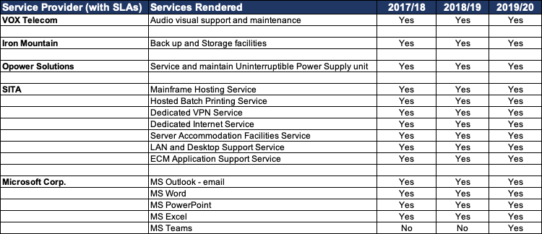

Other relevant details are as follows:
- The DSI procures goods and services using the departmental SCM procurement processes and also complies with the SITA Act and Regulations for the procurement of IT goods and services.
- For the SITA mandated services, the SLA is entered into between the DSI and SITA.
- Service level agreements (SLAs) are entered into between the DSI and respective service providers.

SLAs are annually reviewed by the Auditor General to ensure compliance with the required prescripts.

