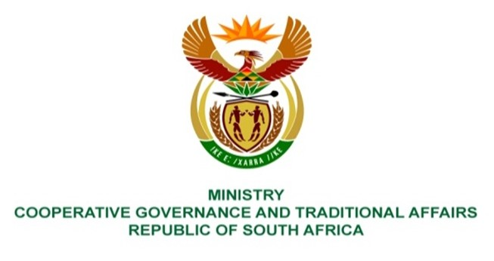

NATIONAL ASSEMBLY
QUESTIONS FOR WRITTEN REPLY

QUESTION NUMBER 2027
DATE OF PUBLICATION: 20 May 2022

QUESTION:
2027. Mrs M R Mohlala (EFF) to ask the Minister of Cooperative Governance and Traditional Affairs:
(1) Whether, with regard to the R17 million bridge that was constructed about two years ago in Ha-Lambani Village outside of Thohoyandou that has already developed cracks because of poor workmanship, her department conducted any quality assurance, monitoring and evaluation prior to the hand over; if not, why not; if so, what are the reasons that the faults were not detected;
(2) Whether the contractor has been (a) instructed to redo the work and/or (b) blacklisted; if not, why not; in each case; if so, what are the relevant details, in each case? NW2370E
REPLY:

- The bridges project mentioned in PQ 2027 belongs to Thulamela Local Municipality (TLM). The pertinent details of the project are outlined below.

The Department of Cooperative Governance (DCOG) is responsible, in terms of section 154 of the Constitution of the Republic of South Africa, Act 108 of 1996 among others, to provide support and strengthen the capacity of municipalities including TLM to manage their own affairs, to exercise their powers and to perform their functions. To that end, DCOG through the Municipal Infrastructure Support Agent (MISA) provides technical support to TLM in accordance with the District Development Model (DDM). The MISA technical support includes the following:

- Development or review of technical reports and other related documentation for project registration at project funding approval stage.
- Development and review of project planning documents, supporting with preparation of procurement documents for service providers.
- Support the municipality by giving technical advice, review reports submitted by the professional service provider appointed by TLM and conduct site inspections.

The cracks on the bridges are part of the defects that the contractor is required to fix within 21 days from the issue of the Practical Completion Certificate done on 23 May 2022. MISA conducts site visits and inspections to monitor the fixing of the defects as part of the support to TLM.

- The contractor was instructed to fix the defects, which include the cracks, within 21 days. The days are counted from 23 May 2022 when the Practical Completion Certificate was issued as indicated in the background above.

