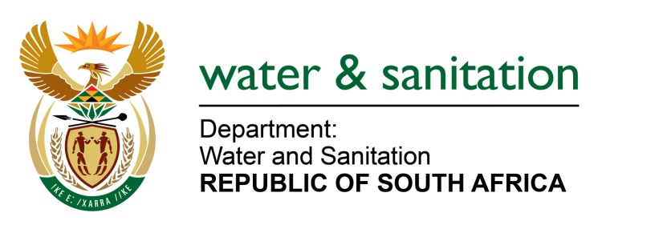

NATIONAL ASSEMBLY

FOR WRITTEN REPLY

QUESTION NO 2026

DATE OF PUBLICATION IN INTERNAL QUESTION PAPER: 26 MAY 2023
(INTERNAL QUESTION PAPER NO. 19)

2026. Mrs C Phillips (DA) to ask the Minister of Water and Sanitation:
Whether, in light of the announcement of the Minister of Health, Mr J Phaahla, that he will be seeking additional supplies of power to be installed at health facilities to augment emergency generators in health care facilities, he, as Minister of Water and Sanitation, will implement similar mitigating measures to ensure that water purification plants and sewerage treatment plants around the Republic, including Rustenburg, can supply both potable water to residents and businesses and grey water to businesses that use grey water, to lessen the burden on our scarce water resource; if not, why not; if so, what are the relevant details? NW2291E
---00O00---

MINISTER OF WATER AND SANITATION
The Minister and department have advised water boards and municipalities to:
- Revise their minimum operational levels for reservoirs
- Increase water treatment and reservoir storage capacity
- Revise water treatment schedules to maximize water treatment while electricity is available or other measures to ensure security of water
- Requiring water boards and municipalities to revise the minimum operational levels for reservoirs
- Develop alternative sources of electricity supply to meet their electricity needs, either through off-take agreements with independent power producers or embedded generators, or through direct ownership. This could include for example, solar panels coupled with inverters and batteries.
- Develop alternative sources of electricity supply to meet their electricity needs, either through off-take agreements with independent power producers or embedded generators, or through direct ownership. This could include for example, solar panels coupled with inverters and batteries.
- Where electricity is supplied from municipality, Water Boards and Water Services Authorities shall, where practically possible and through municipal electricity departments, isolate water and sanitation infrastructure.
- Develop integrated response plans to maintain drinking water and drinkin water and wastewater standards during loadshedding, covering water and sanitation, electricity, and other divisions of the Water Service Authority.

The Department has also requested Eskom to exempt water boards and water service authorities from penalties for exceeding the notified maximum demand during periods of load shedding. Eskom has not yet acceded to this request.

The DWS is also in the process of issuing a Request for Information (RFI) for the private sector to invest in renewable energy generation coupled with energy storage capacity to supply DWS with its electricity needs, based on long-term electricity off-take agreements with DWS. This will incrementally reduce the reliance of DWS on the electricity grid over time.

---00O00---

