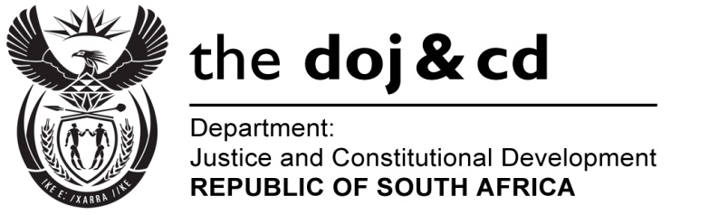
NATIONAL ASSEMBLY
QUESTION FOR WRITTEN REPLY
PARLIAMENTARY QUESTION: NO. 2026
DATE OF QUESTION: NO. 23 SEPTEMBER 2016

DATE OF SUBMISSION: 7 OCTOBER 2016

Ms H S Boshoff (DA) to ask the Minister of Justice and Correctional Services:
What formal qualifications does each of his department’s (a)(i) Chief Financial Officers and/or (ii) acting Chief Financial Officers and (b)(i) Directors-General and/or (ii) acting Directors-General possess?
NW2337E
REPLY:

- The Chief Financial Officer of the Department of Justice and Constitutional Development is in possession of the following formal qualifications:
- Senior Certificate;
- Baccalaurreus Computationis (B.Compt);
- Honneursbaccalaureus Computationis (Hons. B.Compt); and
- Magister Commercii (M.Com).

- The Director-General of the Department of Justice and Constitutional Development is in possession of the following formal qualifications:
- Senior Certificate; and
- Baccallaureus Procurationis (Law).

- The Chief Financial Officer for the Office of the Chief Justice is Mr Casper Nicolaas Coetzer. Mr Coetzer has the following qualifications:
- Matric from Bergsig Hoerskool, Rustenburg
- Bachelor Degree in Commerce obtained from the University of South Africa;
- Certificate in Senior Management from the University of Pretoria;
- Certificate in Organization and Work Study from the former Pretoria Technikon;
- Certificate in Contract Compliance and Performance Monitoring from the Institute for Public Private Partnerships, Washington, DC.
- The Secretary-General for the Office of the Chief Justice, Ms Memme Sejosengwe has the following qualifications:
- Matric from Barolong High School in Mafikeng
- Bachelor of Law Degree from the University of North West;
- Certificate in Organization and Work Study from the Pretoria Technikon;
- Advanced Diploma in Labour Law from Rand Afrikaans University;
- Executive Development Programme from the University of South Africa (UNISA) Graduate School of Business Leadership (SBL)
- Case Flow Management Training from National Centre for States Courts (NSCC), Williamsburg, Virginia, USA

