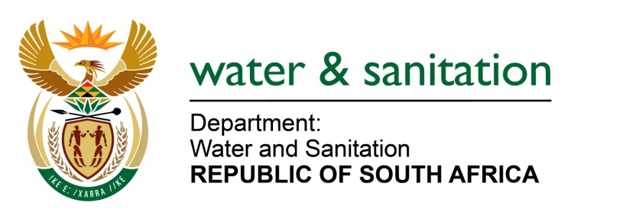

NATIONAL ASSEMBLY

FOR WRITTEN REPLY

QUESTION NO 2025

DATE OF PUBLICATION IN INTERNAL QUESTION PAPER: 26 MAY 2023
(INTERNAL QUESTION PAPER NO. 19)

2025. Mrs C Phillips (DA) to ask the Minister of Water and Sanitation:
Whether he has been informed of the extended water outages experienced by many residents in Rustenburg in the North West due to load shedding at the water purification plant, the sewerage treatment plant that provides grey water to some of the platinum mines and at the pump stations pumping water to both the command and supply reservoirs; if not, what (a) is the position in this regard and (b) mitigating measures will he urgently implement to ensure that residents and businesses do not continue to be deprived of their basic human right of access to water; if so, what mitigating measures has he put in place to prevent the outages from continuing?
NW2290E

---00O00---

MINISTER OF WATER AND SANITATION

- The Department is aware of the water supply interruptions in Rustenburg Local Municipality. Seven urgent notices were issued by the municipality on between February and May 2023 informing consumers of the expected water shortages owing to load shedding and routine maintenance which resulted in Water Treatment Plants not operating optimally and water supply interruptions. The municipality had reported a 40% reduction at the Vaalkop system which has since recovered and is back at 100% supply. However, the Bospoort system is still operating at an average of 85-90% supply.

The supply of treated effluent from the Rustenburg Wastewater Treatment Works to Anglo American and Impala Platinum mines was authorised in the water use authorisations for the mines as a way of promoting the re-use of grey water. At no point is the treated effluent pumped to any water supply reservoirs.

- The municipality began implementing a Water Demand Management Strategy in October 2022 as a mitigation measure. Based on the strategy, water supply is isolated and rotated to specific areas at a time and a schedule has been issued detailing the supply times for different areas.

The municipality has requested Eskom to exempt the Bospoort Water Treatment Works (WTW) from load shedding to mitigate water supply challenges, the request was approved for Stage 2 loadshedding.

In addition, a back-up generator has been leased by the municipality as a preliminary measure. The municipality has indicated that the long-term plan is to solution to water supply interruptions caused by loadshedding to isolate the transformer supplying electricity to the Bospoort WTW to exempt the plant from loadshedding.

---00O00---

