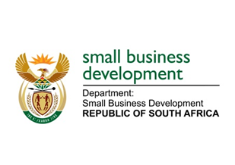
NATIONAL ASSEMBLY
QUESTION FOR WRITTEN REPLY
DUE TO PARLIAMENT: 3 JUNE 2022

2024. Ms B Mathulelwa (EFF) to ask the Minister of Small Business Development:

On what date will she attend to the reported cases of the exploitation of small-, micro- and medium-enterprises by big companies? NW2367E

_________________________________________________________________________________

REPLY: I have been advised by the department as follows:

The exploitation of the SMMEs by the big companies is a concern as well for the DSBD. It is against this background that the DSBD, through the National Small Enterprise Amendment Bill, is in the process of effecting amendments to the National Small Enterprise Act, 1996 (Act No 102 of 1996) to provide for the establishment of the Small Enterprise Ombud Service.

The proposed Office of the Small Enterprise Ombud Service is meant to resolve disputes affecting small enterprises in an economical expeditious and equitable manner without the need to resort to costly litigation. This will include provisions to deal with unfair trading practices that result in the exploitation of small-, micro-, and medium- enterprises.

Regarding the processing of the Bill, public comments have been received and considered. Currently there is an engagement with the Office of the State Law Advisors (OSCLA) for certification and once that is done the Bill will be tabled to Cabinet for approval to be introduced in Parliament.

STELLA NDABENI-ABRAHAMS
MINISTER: DEPARTMENT OF SMALL BUSINESS DEVELOPMENT

