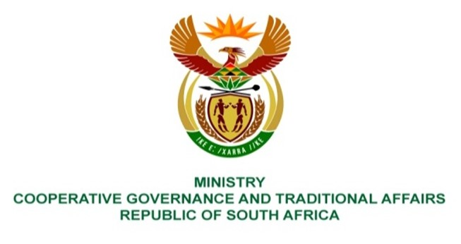

NATIONAL ASSEMBLY
QUESTIONS FOR WRITTEN REPLY

QUESTION NUMBER: 2024

DATE OF PUBLICATION: 27 August 2021

QUESTION:

2024: Mr R A Lees (DA) to ask the Minister of Cooperative Governance and Traditional Affairs:

(1) Whether, with reference to her reply to question 2436 on 13 November 2020, the investigation has been concluded; if not, why not; if so,

(2) whether the information has been obtained; if not, why not; if so, what are the relevant details?

NW2261E

REPLY:

- According to information from Province and the municipality, only Section 106 investigations have been completed. The investigation by the HAWKS on the matter have not been concluded; and

- The information therefore remains unavailable, since the matter is still under investigation by the HAWKS.

