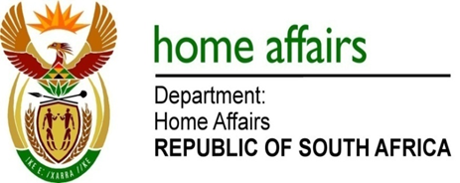

NATIONAL ASSEMBLY

QUESTION FOR WRITTEN REPLY

QUESTION NO. 2021

DATE OF PUBLICATION: FRIDAY, 8 JUNE 2018

INTERNAL QUESTION PAPER 20 OF 2018

2021. Ms NW A MAZZONE (DA) to ask the Minister of Home Affairs:
- What are the details of the (a) number of accidents that vehicles owned by his department were involved (i) in each of the past three financial years and (ii) since 1 April 2018, (b) cost for repairs in each case and (c)(i) number of and (ii) reasons for vehicles being written off in each case;
- Whether all vehicles owned by his department have tracking devices installed?

REPLY:

(1)(a)(i) and (ii) as tabulated hereunder:

 | 2015/16 | 2016/17 | 2017/18 | 2018/19
Number of State owned DHA vehicles involved in accidents | 69 | 72 | 50 | 5
Number of State owned vehicles written off | 15 | 21 | 5 | 1

Please note ‘accidents’ involve all incidents where damage is caused to a State owned vehicle. This includes cracked windscreens and burst tyres.

(1)(b) For detail see schedule attached marked annexure A.
(1)(c)(i) See table above
(1)(c)(ii) Uneconomical to repair

(2) None of the State owned DHA vehicles are fitted with tracking devices.

