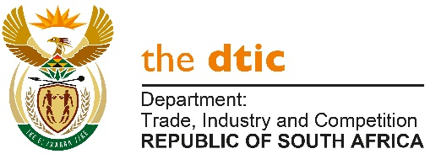
THE NATIONAL ASSEMBLY

QUESTION FOR WRITTEN REPLY

QUESTION NO. 2014

DATE PUBLISHED: 27 AUGUST 2021

Mr D W Macpherson (DA) to ask the Minister of Trade, Industry and Competition:

(1) Whether there has been an investigation by the National Regulator for Compulsory Specifications (NRCS) and/or his department into R4,5 million fraud in the NRCS; if not, what is the position in this regard; if so, what are the full relevant details;

(2) whether 4000 illegally imported flat screen television sets that were seized by the NRCS were stolen from the NRCS warehouse; if not, what is the position in this regard; if so, what are the full relevant details;

(3) what (a) items have been stolen from any premises of the NRCS in the past 12 months and (b) was the total value of the items stolen in each case? [NW2250E]

REPLY:

The CEO of the NRCS, Mr Mamaditse, has provided the Department of Trade, Industry and Competition (the dtic) with the following information.

(1) A case of fraud was detected in the NRCS in December 2020. The NRCS reports that it commissioned a full investigation of the matter which confirmed that fraud amounting to R4,501,488.21 was committed. The disciplinary process is underway and a criminal case has been opened. The NRCS insurers have been notified and are currently assessing the claim. The NRCS reports that it has also reviewed its procedures to mitigate the risk of this type of fraud recurring.

(2) Six hundred and seventy-two (672) illegally imported television sets were handed over to the NRCS on 4 July 2017. The NRCS reports that 641 were stolen and the theft was discovered in December 2018. A criminal case was opened. The NRCS Legal Services unit has been tasked with investigating the matter and is assisting the police investigation.

(3) (i) Losses Due to the Unrest in Durban

One of the NRCS rented warehouse in Durban was looted during the unrest and the full extent of the loss is still in the process of being determined. The warehouse was used to store Electro-technical, Automotive and Chemicals, Materials and Mechanicals products.

- Reported and confirmed Losses over the past 12 Months, excluding the loss arising from looting in Durban.

Premises | - Product | Quantity | - Value
Port Elizabeth | Safety Shoe | 21 | R8 400
Port Elizabeth | Paraffin heaters | 110 | R55 000
Total |  |  | R63 400

The NRCS reports that it is actively addressing the challenges experienced with regard to products being stolen. To this end, the NRCS has appointed a panel of service providers to destroy non-compliant products. In addition, it advises that it has undertaken a review of its storage facilities and will shortly issue a tender to source more secure storage facilities.

-END-

