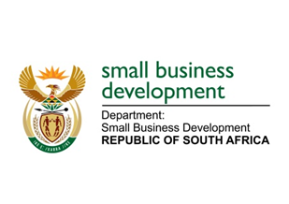
NATIONAL ASSEMBLY
QUESTION FOR WRITTEN REPLY
DUE TO PARLIAMENT: FRIDAY, 9 JUNE 2023

“2008. Mr D F Mthenjane (EFF) to ask the Minister of Small Business Development:
(1) What are the reasons for the Industrial Development Corporation (IDC) to move rapidly towards operating in the small, micro and medium enterprises wholesale lending when the Small Enterprise Finance Agency (SEFA) has been in operation in the sector for more than a decade.
(2) whether the specified move is a sign that SEFA is struggling to fulfil its mandate; if not, what is the position in this regard; if so, what are the relevant details.
(3) whether SEFA should be dissolved, and its functions transferred to the IDC; if not, why not; if so, what are the relevant details?” NW2270E

REPLY:
I have been advised as follows:

- The Industrial Development Corporation (IDC) is an agency under the Department of Trade, Industry and Competition (the dtic). The department has not been apprised of Industrial Development Corporation’s motive to move into the SMME wholesale lending.
- As indicated under (1) above, the motive for the move is not known to DSBD. However, sefa has been delivering on its mandate. To date, since its establishment in April 2012, sefa has disbursed R9.5 billion into the South African economy via the Wholesale Lending channel, supporting 629 971 SMMEs and Co-operatives, who in turn helped create and sustain 767 551 jobs.
- The DSBD is currently undertaking a process of merging sefa and Co-operative Banks Development Agency (CBDA) into the Small Business Development Agency (Seda). The establishment of the new entity will give effect to a Cabinet decision to enable and provide for integrated government support (both financial and non-financial) to small enterprises, which are defined as including Co-operatives.

