MINISTER FOR HUMAN SETTLEMENTS: N C MFEKETO, MP DIRECTOR-GENERAL: M S TSHANGANA

NATIONAL ASSEMBLY

QUESTION FOR WRITTEN REPLY QUESTION NUMBER: PQ 2007 (NW2166E) DATE OF PUBLICATION: 8 JUNE 2018

REPLY RECOMMENDED BY:
s sxo so
CHIEF OPERATIONS OFFICER

NATIONAL ASSEMBLY
QUESTION FOR WRITTEN REPLY QUESTION NUMBER: PQ 2007 (NW2166E) DATE OF PUBLICATION: 8 JUNE 2018

Mr M S Malatsl (DA) to ask the Minister of Human Settlements:
Wlth eference to each domestic trip that was undertaken by board members and senior management of the (a) Housing Development Agency and (b) Community Schemes Ombud Service in each year between 1 January 2014 and 31 December 2017. what are the relevant details in each case of the (I)(aa) name of each hotel and (bb) cost of accommodation of each hotel stay, (il) cost of shuttle service used and (iii) total amount of traveling allowance for each member of the travelling delegationt

REPLY:

- HOUSING DEVELOPMENT AGENCY
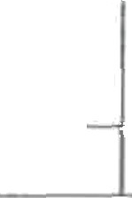
tqtsaJ uai»e or
each hotel
;bbj coat a
accommodefion of each hotal stay
pq cost a tilq T‹aaiampuu
shuttle of traveling service used allowance
BOARD MEMBERS
City Lodge O R Tambo Terminal CU Lodge O R ” Tambo Terminal Albany Hotel Albany Hotel
) Hotel Verde
R 1 282,70
0
0
R 1 282,70“
” Sunnyslde Park
R 648,00
) R 449,00
) R 1 296,45
R 1 110,00
)0
)o
›'
R1000,00“
0
0
0
"
”
The Royal Hotel
Durban
Cir Lodge O R "
R 1 248,00
0
) R 1 323,10
0

2014

Tambo Teizriinal
City Lodge O R R 1 323,10 0
Tambo Terminal
City Lodge O R R 972,00 0 0
Tambo Terminal
City Lodge O R R 972,00 0 0
Tambo Terminal
City Lodge O R R 700,00 0
Tambo Terminal
City Lodge O R R 972,00 0 0
Tambo Terminal
City Lodge O R R 972,00 0
Tambo Terminal
The Royal Hotel R 2 524,00 0 0
Durban
Avis - Housing Dev R 908,44 0 0
Agency Head Office

The Royal Hotel R 1 262,00 Durban
R 951,00 0

Garden Court Sandton City
R 1 411,74 0 0

Avis - Housing Dev R 808,98 Agency Head OBce
Sunnyside Park R 1 300,00 Hotel
City bDdge O R R 3 2*0,00 Tambo Terminal
The Royal Hotel R 1 268,00 Durban
City Lodge O R R 1 363,50
Tambo Terminal
Avis - Housing Dev R 945,95 Agency Head Office
City Lodge O R R 1 300.00 Tambo Terminal

R 515,00 0

0

0

0

0

0

(i)(aa) Name of each hotel

(bb) cast of" (li) Coet of (iii) Total amount accommodation of shuttle of traveling
each hotel etay gerviCe used allowance

The Royal Hoel R 1 262,00 0 0
Clty Lodge Sandton R 2 200,00
0
0

R 1 471,08 0

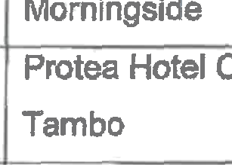
Protea Hotel O R R 1 431,08
Momingside Protea Hotel O R Tambo
QT b
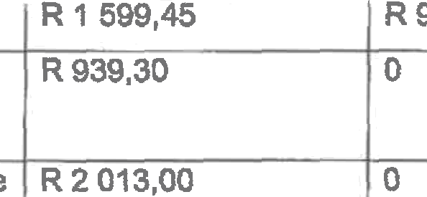
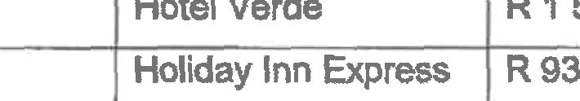
2014 SENIOR IgANAGEMENT
CapHetege Hotel R 3 200,00
i!0
Hotel Verde |  | R 1 296,45 |  |  |  |  |  | R 1 233,00 |  |  |  | 0
Hotel Verde |  | R 1 599,45 |  |  |  |  |  | R 965,00 |  |  |  | 0
Holiday Inn Express |  | R 939,30 |  |  |  |  |  | o |  |  |  | o
Umhlangs
Rustenburg Boutique |  | R 2 013,00 |  |  |  |  |  | 0
Hotel
Hollow On The |  | R 2 165,00 |  |  |  |  |  | 0
Squsre
Cape Town Lodge |  | R 995,00 |  |  |  |  |  | 0 |  |  |  | ’0
Cape Town Lodge |  | R 1 190,00 |  |  |  |  |  | 0 |  |  |  | 0
Cape T dge |  | R 995,00 |  |  |  |  |  | 0 |  |  |  | 0
Cape To L d e |  | R 995,00 |  |  |  |  |  | 0 |  |  |  | 0
Cape Town Lodge |  | R 1 120,00 |  |  |  |  |  | 0 |  |  |  | 0
Sibaya Lodge |  | R 9 32 |  |  |  |  |  | 0 |  |  |  | 0
Cspe Town Lodge |  | R 1 444,00 |  |  |  |  |  | 0 |  |  |  | 0
Townhouse Hotel & |  | R 1215,00
' Conference Centre
( Cape Town Lodge |  | R 1 990,00
Cape Town Lodge |  | R 995,00 |  |  |  |  |  |  |  |  |  | 0
Townhouse Hotel & |  | R 928,00“ |  |  |  |  |  |  |  |  |  | 0
Conference Centre
Cape Town Lodge |  | R 9g5,00
Cape Town Lodge |  | R 1 100,00
Cape TowndLue |  | R 995,00 |  |  |  |  |  | 0 |  |  |  | 0

0

I°

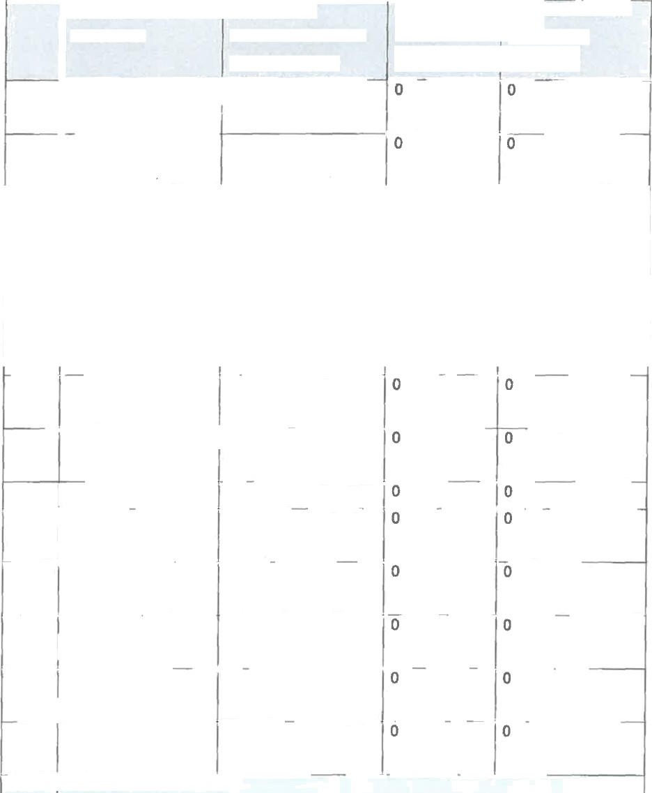
&j(aa) xame oi ' ‹bb) cost« liij costd {lily ast amoum
each hotel accommodation of shuttle oft›aveIing
each hotel stay service used allowance
Townhouse Hotel &“ R 2 190,00 Conference Centre

Townhouse Hotel & R 1 095,00
Conference Centre

2015 ”BOARD MEIgBERS
City Lodge O R R 1 615,00 0
Tambo Terminal '
City Lodge O R R 1 137,00 lO 0
Tambo Terminal

Avis - Housing Dev R 874,37 0
Agency Head Office
Sunnyside Park R 1 300,00
Hotel
Avis - Housing Dev R 505,84 Agency Head Office
Birchwood Hotel R 1 175,10 Avis - Housing Dev R 638,59 Agency Head Office
Protea Hotel 0 R R 1 306,51 Tambo
Southern Sun O.R. R 1 498,38 Tambo Airport
Southern Sun O.R. R 1 531,52
Tambo Airport
Southern Sun O.R. R 1 608,23

Tambo Airport
20'I5 I SENIOR MANAGEiYIENT
l _.

Hotel Verde R 1 285,00 0
Pepper Club Hotel R 1 500,00 ‹° 0
 | Inn On The Square | R 1 300,00 |  |  |  | 0 |  |  |  | !“0
 | Sunnyside Park | R 1 300,00 |  |  |  | 0
 | Hotel
 | Protea Hotel Knysna  Quays | R 1 134,25 |  |  |  | 0 |  |  |  | i0
 | Hotel Verde | R 1 564,00 |  |  |  | 'O

  - t= jaamed jbaj cost «

eacn hucwi e• ••aIxx• *-**£

yl) co«t o7 {lift Taa1a«ount

each hotel s sy service used III we‹›w
 | Hotel Verde | R 1 564,00 | 0 | 0
 | Hotel Verde | R 1 564,00 | R 1 200,00 | 0
 | Hntel Verde | R 1 564,00 | 0 | 0
 | Hotel Verde | R 1 564,00 | 0 | 0
 | Protea Hotel | R 1 311,25 | 0 | 0
 | Wanderers
 | Protea Hotel | R 1 617,25 | 0 | 0
 | Wanderers
 | Hotel Verde | R 1 442,80 | 0 | 0
 | Garden Court Kings | R 1 446,10 | 0
 | Beach
 | Protea Hotel | R 1 300,00 | 0
 | Parktonian
 | Protea Hotel | R 1 300,00 | 0
 | Parktonian
 | Cape Town Lodge | R 1 100,00 | 0 | 0
 | Hotel Verde | R 1 692,80 | 0 | 0
 | Hotel Verde | R 1 442,80 | R477,00 | 0
 | Beachwalk Bed & | R 1 065,00 | 0 | 0
 | Breakfast
 | City Lodge O R | R 1 300,00 | 0 | 0
 | Tambo Terminal
 | Protea Hotel Marine | R 2 617,B0 |  | 0
 | Hampshire Hotel | R 1 870,00 | 0 | 0
 | Cape Town Lodge | R 1 100,00 |  | 0
 | Garden Court Kings | R 1 378,3b |  | 0
 | Beach
 | Protea Hotel | R 2 600,00 | 0 | 0
 | Parktonian
 | Hilton Hotel Durban | R 1 300,00 | 0 | 0
 | Hilton Hotel Durban | R 1 300,00 | 0
 | Raginson Btu Hotel | R 5 184,10 | 0 | 0
 | Port Elizabeth

6

Town Lodge Port Elizabeth | R 3 352,00 |  | 0 | 0
Radisson Btu Hotel | R 1 300,00 |  | 0
Port Elizabeth
Saint George Hotel & | R 948,00 |  |  | 0
Convention Centre
Protea Hotel | R 1 300,00 |  | 0 | 0
Parktonian
Garden Court | R 1 160,20 |  | 0 | 0
Polokwane
Protea Hotel | R 1 300,00 |  | 0 | 0
Parktonian
Royal Palm Hotel | R 1 590,00 |  | R 7 550,00 | 0
(Rph)
Protea Hotel | R 1 615,75 |  | 0 | 0
Wanderers
Cape Town Lodge | R 1 160,00 |  | 0 | 0
Cape Town Lodge | R 2 110,00 |  | 0 | 0
City Lodge Port | R 3 900,00 |  |  | 0
Elizabeth
Courtyard Port | R 1 235,00
Elizabeth
Fusion Boutique  Hotel | R 5 019,30 |  |  | 0
Protea I-totel | R 1 426,75 |  | 0
Umhlanga Ridge
City Lodge O R | R 1 484,70 |  |  | 0
Tambo Terminal
City Lodge Port | R 1 300,00 |  | 0 | 0
Elizabeth
City Lodge Port | R 1 300,00 |  | 0 | 0
Elizabeth
Townhouse Hotel & | R 2 390,0D |  | 0 | 0
Conference Centre

ql) Cost of (ill Total amount
SnL!*-" sat xs-‹ 1»iZ g

each hotel atay ---rr' .• - allow an«-s
Townhouse Hotel & R 2 690,00 0 0 Conference Centro

City Lodge Port R 1 300,00 Elizabeth
Radisson Biu Hotel R 3 119,05 Port Elizabeth
0

R 5 600,00 0

Radisson Btu Hotel R 1 300,00 0 0
Port Elizabeth
Cape Town Lodge R 2 252,00 0 0
Cape Town Lodge R 1 249,00 0 0
City Lodge Port R 1 300,00 0
Elizabeth
St‹and Tower Hotel R 1 300,00 0 0
Sunnyside Park R 1 300,00 0 0
Hotel
Protea Hotel Fire & R 1 310,75 0 0
Ice! Cape Town

Protea Hotel Parktonian Garden Court Polokwane
R 1 300,00 0 0

R 903,00 0

Fifth Avenue Beach R 800,00 0 0

House

Protea Hotel Wanderers
R 6 403,37 0 0

Radisson Btu Hotel R 1 300,00 0
Port Elizabeth
Clty Lodge Port R 1 314,64 0 0
Elizabeth

Radisson Blu Hotel R 1 300,00 0
Port Elizabeth

Hilton Hotel Durban R 1 300,00 The Boardwalk R 3 9g5,00 Casino & Enterta
(Bet)
0 0
R 10 550,00 0

li)la«jx°•«°r lbaj•=t-:
6aCh hot8l efioum£I3••xao•‹•a••

each hotel stay'

Hilton Hotel Durban R 1 300,00

Hilton Hotel Durbsn R 1 300,00
Hilton Hotel Durban R 2 839,00
Hilton Hotel Durban R 4 200,00 No S Botique Art R 1 778,65 Hotel
R506,00 0
Rsog,oo o
0 0
R 13 700,00 0
R 6 250.,00 0

Direct Hotels

Montarey
R 2 806,76 0 0

Hilton Hotel Brisbane R 9 646,56 0 0
Western Gateway R 2 134,22 0
Motel

Courtyard Port Elizabeth Protea Hotel Parktonian Courtyard Port Elizabeth
R 1 100,00 0 0

R 1 308,80 0

R 1 100,00 0 0

Radisson Btu Hotel R 3 600,00 0 0
Port Elizabeth
Protea Hotel Fire & R 1 310,75 0
Ice! Cape Town
Radisson Btu Hotel R 1 300,00 0

Port Elizabeth

Southern Sun Cape R 1 159,50 Sun
R 1 000,00 0

Southern Sun Cape R 4 353,70 0 0
Sun

Sunnyside Park R 1 300,00 0 0
Hotel
Sunnyside Park R ‘I 300,00 0

HoteJ

Sunnyside Park R 1 300,00 0 0
Hotel
Sunnyside Park R 1 300,00 0

Hotel

(I)(aa) Name of (bb) Co» I (1i) Cost of (lii) Total amount
each hotel a «moe«Io n of shuttle « «ii«g
each hotbi say s•rvi=• •••isd allowance Sunnyside Park R 1 300,00 0 0
Hotei
Southern Sun Cape R 1 796,85 0
Sun
City Lodge Port R 1 225,B5 0 0

Elizabeth
Townhouse Hotel & R 1 080,00 0 0
Conference Centre

Townhouse Hotel & R 1 185,00 0
Conference Centre
Stay Easy Century R 1 008,99 0
City
Protea Hotel R 1 308,80 0

Parktonian
15 On Orange Hotel R 3 735,00 0 0
Marlot Guest House R 7eo,oo 0
Garden Court Kings R 2 700,70 0 0
Beach
Radisson Btu Hotel R 2 519,40 0 0
Port Elizabeth
Southern Sun O.R. R 1 187,46 0 0
Tambo Airport
Sunnyside Park R 1 300,00 0 0
Hotel
Townhouse Hotel & R 1 165,00 0
Conference Centre

Protea Hotel
Bloemfontein Central
R 1 213,02 0 0

Town Lodge Port R 1 238,00 0 0

Elizabeth

Southern Sun Bloemfontein
R 1 305,60 0 0

Radisson Btu Hotel R 1 300,00 0 0
Port Elizabeth

10

 | (I)(aa) Nsme of  each hotel | (bb) Cost of  accommodation of  each hotel stay | (ii) Cost of  shukle  service used | (lil) Total amoont  of traveling  allowance
 | Radieson Btu Hotel  Port Elizabeth | R 1 302,90 | 0 | 0
 | Townhouse Hotel &  Conference Centre | R 1 180,00 |  | 0
 | Garden Court Kimberley | R 1 407,65 | 0 | 0
 | Garden Court  Polokwane | R 3 189,40 |  | 0
 | Protea Hotal Fire &  feel Cape Town | R 1 310,75 | 0
 | Radisson Btu Hotel  Port Elizabeth | R 2 600,00 | 0 | 0
 | Protea Hotel Fire &  Ice! Cape Town | R 2 921,50 | 0 | 0
 | Protea Hotel Fire &  Ice! Cape Town | R 1 310,75 | 0 | 0
 | Protea Hotel Fire &  Ice! Cape Town | R 2 701,50 | 0 | 0
 | Premier Hotel O.R.  Tambo | R 1 290,00 | 0
 | Radisson Btu Hotel  Port Elizabeth | R 1 300,00 |  | 0
 | Hilton Hotel Durban | R 2 847,00 | 0 | 0
 | Courtyard Port  Elizabeth | R 1 100,00 | 0 | 0
 | Radisson Btu Hotel  Port Elizabeth | R 1 300,00 | 0 | 0
 | Hilton Hotel Durban | R 2 600,00 |  | 0
 | Courtyard Port  Elizabeth | R 2 200,00
 | Protea Hotel Sea  Point | R 1 309,50 | 0 | 0
2016 | BOARD MEMBERS
 | Avis - Housing Dev  Agency Head Office | R 813,98

”{fjjéa) same of ' (a») c%t «.
zzch otei ia w« m-. »•s w•
(II) Gnet of (Hi) TataJ aiiiount
*• • •- » w lan qp

each hotel sh y
Avis - Housing Dev R 1 417,12 0 0
Agency Head Bffice

Protea Hotel Wanderers Protea Hotel Wanderers
R 4 236,45 0 0

R 1 412,15 0 0

Avis - Housing Dev R 1 109,68 0 0
Agency Head Office
Avis - Housing Dev R 811,04 0 0
Agency Head Office

Protea Hotel Wanderer Protea Hotel Wanderers Protea Hotel
Wanderers
R 1 412,15 0 0

R 3 056,80 0

R 3 371,30 0 0

Empire Executive R 1 300,00 0 0

Apartments & Hotel

Protea Hotel Marine R 1 309,00
Empire Executive R 2 600.00 Apartments & Hotel
Empire Executlve R 1 300,00 Apartments & Hotel
Empire Executive R 1 350,00 Apartments & Hotel
R 580,00 0
R 1 050,00 0

R 4 100,00 0

R 1 050,00 0

Protaa Hotel Fire & R 3 246,00 0 0
Ice! Melrose Arch
Velmore Conference R i g39,oo 0 0
Centre

Velmore Conference R 1 639,00 Centre
Empire Executive R 1 350,00 Apartments & Hotel
0 0

R e00,00 0

Empire Executive R 1 500,00 0 0

Apartments & Hotel
12

 | (i)(aa) Marne of  each hotel | (bb) Cost of  accommodation of each hotel stay | (li} co»t of  shuttle service used | (ii¿ Solar amount  of traveling allowance
 | 20 West Hotel And  Apartments | R 1 440,00 | 0 | 0
 | Protea I-foteI Edward | R 1 350,00 | 0 | 0
 | Premier I-IoteI O.R.  Tambo | R 1 300,00 | 0 | 0
 | SENIOR MANAGEMENT
 | Protea Hotel  Parktonian | R 2 817,60
 | Holiday Inn E›‹press  Sunnypark | R 1 050,00 | 0 | 0
 | Protea Hotel Fire &  Ice! Cape Town | R 1 310,65 | 0 | 0
 | Protea Hotel  Parktonian | R 1 308,80 |  | 0
 | Courtyard Port  Elizabeth | R 1 300,00 | 0 | 0
 | Hotel Colon | R 8 880,00 | 0 | 0
 | Radisson Btu Hotel  Port Elizabeth | R 1 300,00 | 0 | 0
 | City Lodge Port  Elizabeth | R 1 100,00 | 0
 | Protea Hotel  Balslaika Sandton | R 2 619,50 | 0 | 0
 | Protea Hotel Marine | R 2 617,60 | 0 | 0
 | Radisson Btu Hotel | R 2 519,40 | 0 | 0
 | Town Lodge Port  Elizabeth | R 1 010,00 |  | 0
 | Protea Hotel  Parktonian | R 1 308,70 |  | 0
 | Protea Hotel The  Ranch & Lion Park | R 1 308,50 | 0 | 0
 | Radisson Btu Hotel  Port Elizabeth | R 2 600,00 | 0 | 0

13

p9 coa: u (iiq Tou‹amu-i

each hw‹ol may
Protea Hotel Fire & R 1 480,65 0 0
Ice! Cape Town
Townhouse Hotel & R 1 zgs,oo 0 0
Conference Centre
Radisson Blu Hotel R 1 300,00 0
Port Elizabeth
Radisson Blu Hotel R 1 J59,70 0 0
Port Elizabeth
Radisson Btu Hotel R 1 259,70 0 0
Port Elizabeth
Radisson Btu Hotel R 1 259,70 0 0
Port Elizabeth
Radisson Btu Hotel R 1 259,70 0 0
Port Elizabeth

Premier Hotel Knysna
R 1 250,00 0 0

Radisson Btu Hotel R 1 259,70 0
Port Elizabeth

Premier Hotel

Knysna
R 1 250,00 0 0

Radisson Bio Hotel R 1 300,00 0
Port Elizabeth
Radisson Btu Hotel R 1 259,70 0 0
Port Elizabeth
Radisson Btu Hotel R 1 300,00 0
Port Elizabeth
Protea Hotel R 1 550 00 0 0
Parktonian
The Reef Hotel R 1 300,00 0
City Lodge Port R 2 600,00 0 0
Elizabeth
Protea Hotel Marine R 1 309,00 0
Protea Hotel Marine R 1 309,00 0
Protea Hotel Marine R 2 618,00 0 0
Protea Hotel Marine R 1 300,00 0 0

(II) Cost of (III) Tdtal amount

each hotsl s•ay
Protea Hotel Marine R 1 309,00 0
City Lodge Port R 2 105,00 0
Elizabeth
Protea Hotel King R 1 300,00 0 0
George
Protea Hotel Fire & R 1 300,00 0 0
Ice! Cape Town
Protea Hotel Fire & R 5 050,00 0
Ice! Cape Town
Protea Hotel Fire & R 4 562,50 0
IceI Cape Town
Sunnyside Park R 1 300,00 0

Hotel
Town Lodge Port R 1 281,07 0 0
Elizabeth
Radisson Btu Hotel R 1 562,00 0 0

Port Elizabeth
Radisson Btu Hotel R 1 359,00 0
Port Elizabeth
Radisson Btu Hotel R 2 519,40 0 0
Port Elizabeth
Premier Hotel O.R. R 1 250,00 0

Tambo
Protea Hotel Marine R 2 600,00 0

Protea I-lotel Marine R 2 too.oo
Protea Hotel Marine R 1 300,00 0
Protea Hotel Marine R 1 300,00 0
Radisson Btu Hotel R 1 300,00 0 0
Port Elizabeth

Radisson Btu Hotel R 5 038,80 0
Port Elizabeth
P.edisssn Btu Hotel R ? 770,10

Port Elizabeth
Radisson Btu Hotel R 8 038,35 Port Elizabeth

(I)(aa) Name of (bb) Cost of

each hotel stay
Radisson Btu Hotel R 5 200,00 0 0
Port Elizabeth
Radisson Btu Hotel R 1 259,70 0
Port Elizabeth
Radisson Btu Hotel R 2 519,40 0 0
Port Elizabeth
Radisson Btu Hotel R 2 519,40 0
Port Elizabeth
Town Lodge Port R 1 035,00 Elizabeth
Radisson Btu Hotel R 1 534,00 0
Port Elizabeth
Radisson Btu Hotel R 1 256,70 0
Port Elizabeth
Radisson Btu Hotel R 6 298,50 0 0
Port Elizabeth
Radisson Btu Hotel R 1 259,70 0
Port Elizabeth
Saint George Hotel & R 1 708,66 0 0
Convention Centre
Sband Tower Hotel R 1 300,00 0 0
Protea Hotel Fire & R 1 300,00 0
Ice! Cape Town
Protea Hotel Fire & R 1 300,00 0 0
lcel Cape Town
Protea Hotel Marine R 3 100,00 0 0
Radisson Btu Hotel R 3 900,00 0
Port Elizabeth
Radisson Btu Hotel R 1 259,70 0
Port Elizabeth
Radisson Blu Hotel R 1 259,70 0 0

Pert Elizabeth
Protea Hotel Marine R 1 550,00 0 0
Protea Hotel Fire & R 3 100,00 0 0
Ice! Cape Town
16

yj(aa) same af ‹bbj c»i «: jlt) cut ? (iiij Tooi amoum

@@/h h * * @ £€ 7E££MX•8Mt•4 . II £ €s• * M M vI***

each hotel stay aeivlce c seo oil- °-—
Protea Hotel Fire & R 1 400,00 R 400,00 - Icel Cape Town
Protea Hotel Fire & R 3 000,00 0
Ice! Cape Town
Protea Hotel Fire & R 1 300,00 Ice! Cape Town
Radisson Btu Hotel R 10 077,60 0 0
Port Elizabeth
Radisson Btu Hotel R 3 900,00 0 0
Port Elizabeth

Radisson Btu Hotel R 1 259,70 Port Elizabeth
Cape Town Lodge R 1 450,00
Radisson Btu Hotel R 6 424,50 Port Elizabeth
0 0

0 0

R 1 300,00 0

Velmore Conference R 1 639,00 0 0
Centre
Carters Rest Guest R 670,00 0 0
House
Southern Sun R 1 550,00 0 0

Bloemfontein
Radisson Btu Hotel R 3 779,10 0
Port Elizabeth
Radisson Btu Hotel R 1 259,70 0
Port Elizabeth
Radisson Btu Hotel R 2 519,40 0 0

Radisson Btu Hotel R 1 850,55 0

Port Ellzabeth
Sunnyside Park R 1 300,00 0
Hotel
Villa Simonne Guest R 4 050,00 0
Lodge & Boutique Hotel

17

(1)(aa) Nams of (bb) Cost a?

each hotel slay e--ivi• u- all= a •»
Villa Simonne Guest R 4 050,D0 0 0 Lodge & Boutique
Hotel
Villa Simonne Guest R 4 050,00 0
Lodge & Boutique Hotel
Villa Simonne Guest R 4 050,00 Lodge & Boutique
Hotel

Protea Hotel
Bloemfontein
R 3 100,00
R 45,00 0

Cape Town Lodge R 2 800,00 0 0
City Ladge R 1 189,60 0
Bloemfontein
Protea Hotel The R 1 225,40 0 0

Ranch & Lion Park

Protea Hotel
Balalaika Sandton
R 2 700.00 0 0

Protea Hotel Marine R 1 550,00
Protea Hotel Marine R 1 550,00 0
Protea Hotel Marine R 1 550,00 0 0
The Royal Hotel R 2 880,00 0 0 Durban
Protea Hotel Marine R 1 400,00 0
Cape Town Lodge R 1 400,00 0 0
Radisson Btu Hotel R 1 405,45 0
Port Elizabeth

Garden Court

Umhlanga
R 2 800,00 0

Frontier Inn & Casino R 2 800,00 0
Macdonalds Lodge R 2 090,00 0 0

Protea Hotel Marine R 2 800,00
Premier Hotel R 2 490,00 0 0
Pinatown

jij{aaj nameo jbbj cast d jflj cost 4 {my Ydat amount
each kotei •• »« • • »•<.•• •toiveiing

eacl› h‹›tel stay e••••- ••- -!l “=nce

Protea Hotel Bloemfontein
R 1 550,00 0 0

Radisson Blu Hotel R 1 405,45 0 0

Port Elizabeth
Radisson Btu Hotel R 1 405,45 0 0
Port Elizabeth
Radisson Btu Hotel R 2 810,90 0
Port Elizabeth
Umthunzi Boutique R 2 480,00 0 0

HoteJ

Golden Horse Casino Hotel Protea Hotel Balalaika Sandton
R 1 350,00 0 0

R 2 700,00 0 0

Hotel Verde R 1 300,00 0 0
Protea Hotel Fire & R 1 400,00 0
lcel Cape Town
Protea Hotel Fire & R 2 800,00 0
Ice! Cape Town
Protea Hotel Fire & R 1 400,00 0 0
Ice! Cape Town

Protea Hotel Parktonian
R 1 550,00 0

Protea Hotel Marine R 3 100,00 0 0
Protea Hotel Fire & R1 400,00 0

Ice! Cape Town

City Lodge

Umhlanga Ridge
R 4 054,62 0

Protea Hotel The R 1 225,40 0
Ranch & Lion Park
Cape Town Lodge R 1 530,00
Pmtea Ho?e! R 2 900,00 0

Balalaika Sandton
Umthunzi Boutique R 2 480,00 0 0

Hotel

(I)(aa) Name of (be) Can of

Southern Sun

Bloemfontein
each hotel y
R 5 400,00 0 0

Protea Hotel Fire & R 7 000,00 0
Ice! Cape Town

Protea Hotel Kimberley
R 1 550,00 0 0

Radisson Btu Hotel R 1 259,70 0 0
Port Elizabeth
Protea Hotel Clarens R 1 400,00 0
Amani Boutique R 1 120,00 0 0
Hotel
Radisson Btu Hotel R 2 810,90 0 0
Port Elizabeth

Kievits Kroon Country Lodge Estate
Protea Hotel Parktonian
R 1 350,00 0

R 2 800,00 0 0

Paxton Hotel R 1 125,00 0
Protea Hotel Willow R 4 120,00 0
Lake
Protea I-loteI Edward R 1 400,00 0
Protea Hotel Fire & R 1 550,00 0 0
Ice! Cape Town
Protea Hotel Fire & R 1 M0,00 0
Ice! Cape Town
Villa Simonne Guest R 4 935,00 0 0
Lodge & Boutique Hotel

Southern Sun Bloemfontein Southern Sun Bloemfontein Southern Sun Emnotweni
R 3 600,00 0 0

R 1 200,00 0 0

R 1 466,46 0

each hotel

Protea Hotel

Umhlanga

each hotel stay service used R 1 400,00
(tit) Total amount

Hilton Hotel Durban R 2 800,00
Townhouse Hotel & R 1 449,00 Conference Centre
Riverside Hotel & R s g31,65 Spa
R 920,00

Hilton Hotel Durban Hilton Hotel Durban Hilton Hotel Durban Protea Hotel Umhlanga

R 5 600,00
R 3 500,00
R 5 600,00
R 1 400,00

Protea Hotel Fire & R 1 550,00

Protea Hotel Fire & R 1 550,00

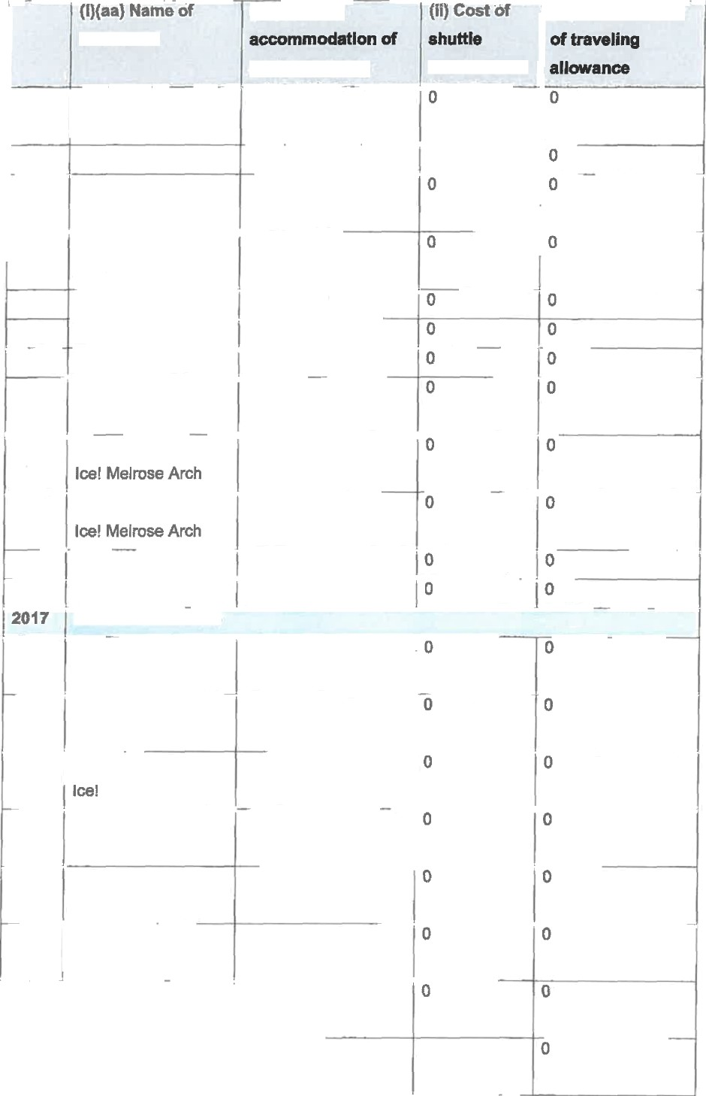
Namakwari Lodge R 1 468,00

Protea Hotel Clarens R 1 200,00 BOARD MEMBERS
Radisson Btu Le R 3 100,00
Vendome
City Lodge O R R 1 550,00 Tambo Terminal
Protea Hotel Fire & R 1 727,00 Melrose Arch
Empire Executive R 3 100,00 Apartments & Hotel
Empire Executive R '\ 489,00 Apartments & Hotel
Empire Executive R 1 550,00 Apartments & Hotel
Empire Executive R ’‹ 550,00 Apartments & Hotel
Empire Executive R 1 550,00

Apartments & Hotel

R 840,00

2t

(I)(da) Néme of (bb) Cos I each hotel . .« • =an =•
@CI3 nu“+I C g Empire Executive R 1 550,00 Apartments & Hotel
Townhouse Hotel 8 R 2 990,00
Conference Centre
Townhouse Hotel & R 2 990,00

Conference Centre
Townhouse Hotel & R 8 192,00 Conference Centre
Townhouse Hotel & R 2 990,00 Conference Centre

Radisson Blu Hotel R 2 867,50 Sandton
Radlsson Btu Hotel R 1 916,00 Sandton

Radisson Btu Hotel R 1 916,00
Sandton
Hotel Verde R 1 275,80
City Lodge O R R 2 700,00

Tambo Terminal
City Lodge 0 R R 3 10D,00
Tambo Terminal
City Lodge O R R 1 550,00
Tambo Terminal
(II) Céat df (llg Tdtél amouzit
z-" :• .• ' Ing
-• ' !I °an•

0 0

R 550,00 0

0

R 550,00 0

R 550,00 0

0 0

R 580,00 0

R 1 000,00 0
R 1 000,00 0

R 600,00 0

0

Premier Hotel El Ice - R 1 425,00 0 0
East London
City Lodge V & A R 1 550,00 0
Waterfront
City Lodge V & A R 1 550,00 0
Waterfront

Villa Simonne Guest R 1 400,00 Lodge & Boutique
Hotel
R S00,00 0

Villa Simonne Guest R 1 400,00 0 0
Lodge & Boutique
Hotel

 | jl7(°•› nama o  each hotel | {bay cost «  accommodation of  each hotel stay | {tfi cot w  shuttle  service used | (iiij otalamount  of bawling  allowance
 | Villa Simonne Guest  Lodge & Boutique  Hotel | R 1 400,00 | 0 | 0
 | Protea Hotel Fire &  Ice! Melrose Arch | R 1 550,00 |  | 0
 | Villa Simonne Guest Lodge & Boutique Hotel | R 2 800,00 |  | 0
 | City Lodge  Umhlanga Ridge | R 1 550,00 | R 650,00 | 0
 | The Capital Nloloko | R 3 400,00 |  | 0
 | The Capital Moloko | R 3 400,00
 | The Capital Moloko | R 1 550,00 |  | 0
 | City Lodge V 8 A Waterfront | R 1 550,00 | 0
2017 | SENIOR MANAGEMENT
 | City Lodge  Umhlanga Ridge | R 1 250,00 | 0 | 0
 | Southern Sun  Bloemfontein | R 3 600,00 | 0 | 0
 | Radisson Btu Le  Vendome | R 1 550,00 | 0 | 0
 | City Lodge Grand  West | R 1 400,00 |  | 0
 | City Lodge Durban | R 1 454,50 | 0 | D
 | City Lodge  Umhlanga Ridge | R 5 649,88 | 0 | 0
 | Protea Hotel Marine | R 1 400,00 | 0 | 0
 | Protea Hotel Fire &  Ice! Melrose Arch | R 3 100,00 | R 552,00 | 0
 | Protea Hotel Fire &  Icel Melrose Arch | R 3 100,00 | 0 | 0
 | City Lodge Grand  West | R 2 800,00 |  | 0
 | Strand Tower Hotel | R 2 800.00 |  | 0

{Ij(»ajxaae« {bbjso«i•: y c<a:•: ) yiyYot«iamovnt
8BCf3 hO ! DCC firs•M •••4l - a t•• ' ! - -3gl4ua 6BCh f3xa4wt,8g&g +x I! _x.
Radisson Btu Le | R 1 550,00 | 0 |  | 0
Vendome
Southern Sun | R 4 908,00 | 0 |  | 0
Bloemfontein
Protea Hotel Knysna | R 1 400,00 | 0
Quays
Protea Hotel | R 1 200,00 | 0 |  | 0
Umhlanga
Radisson Btu Hotel | R 1 455,95 | 0 |  | 0
Port Elizabeth
Radisson Btu  Elizabete Hotel | R 2 911,90 | 0 |  | 0
Radisson Btu Le | R 1 500,00 | 0 |  | 0
Vendome
Protea Hotel Marine | R 1 400,00 | 0 |  | 0
Protea Hotel Fire & | R 1 733,00 | 0
IceI Melrose Arch
Crystal Towers Hotel | R 5 000,00 | 0 |  | 0
Radisson Blu Le | R 1 850,00 | 0 |  | 0
Vendome
Protea I•IoteI Fire & | R 8 165,85 | 0 |  | 0
Ice! Cape Town
Premier Hotel | R 1 375,00 |  |  | 0
Knysna
Southern Sun | R 2 675,00 | R 500,00 |  | 0
Bloemfontein
Protea Hotel | R 1 400,00 | 0 |  | 0
Balalaika Sandton
Protea Hotel Fire & | R 1 550,00 | 0 |  | 0
Ice! Cape Town
Radisson Btu Hotel R 1 405,45  Port Elizabeth |  | 0 | 0
Radisson Btu Hotel R 1 658,95 |  | 0 | 0

Port Elizabeth

24
1

‹ij{aaj same of (ab)cal•: yy caa « {‹fly ot«l aaé«nt
»a«h hotel a ---• -••• ••• one =• wv» =
each hotel stay .» :l all •-

City Lodge

Umhlanga Ridge
R 1 250,00 0 0

HDtel Verde R 2 800,00 0 0

Protea Hotel Cape R 1 200,00 0 0
Castle
Protea Hotel Cape R 1 400,00 0 0
Casde
Protea Hotel Cape R 1 400,00 0
Castle
The Capital Mirago R 2 130,65

The Capital £/lirage R 2 050,00 0 0
Protea Hotel Fire & R 3 450,00 0
Icel Melrose Arch

City Lodge Bloemfontein
R 1 400,00 0

Radisson Btu Hotel R 1 405,45 0 0

Port Elizabeth

Protea Hotol Umhlanga Protea Hotel Kimberley Crown Hotel &
Conference Gentre

R 1 200,00 0

R 1 386,14

R 1 045,00

Protea Hotel Fire & R 1 388,14 Ice Menlyn

Kievits Kroon Country Lodge Estate
Kievits Kroon Country Lodge Estate
Kievits Kroon Country Lodge Estate
R 3 000,00 0 0

R 3 000,00 0

R 3 000,00 0

(i)(aa] Naane of ,bb) Ca I ,{if›coei « ”(ilg Toa‹«maunt

.,- ••-•.•=. all.owance
Protea Hotel Fire & | R 1 550,00 | 0 | 0
Ice! Melrose Arch
Radisson Btu Hotel | R 1 405,45 | 0
Port Elizabeth
Radisson Btu Hotel | R 1 405,45 | 0 | 0
Port Elizabeth
Protea Hotel Fire & | R 1 400,00 | 0 | 0
feel Cape Town
Protea Hotel  Balalaika Sandton | R 4 200,00 | 0 | 0
City Lodge | R 1 400,00 | 0
Bloemfontein
Protea Hotel Fire & | R 1 400,00 | 0
Ice! Cape Town
Protea Hotel Fire & | R 2 800,00 |  | 0
Ice! Cape Town
Stay Easy Century | R 1 079,69 | 0 | 0
City
Protea Hotel Fire &  IceI Cape Town | R 1 550,00 |  | 0
Radisson Btu Le | R 1 550,00 | 0 | 0
Vendome
Radisson Btu Hotel | R 1 405,45 |  | 0
Port Elizabeth
City Lodge  Umhlanga Ridge | R 4 040,00 | 0 | 0
City Lodge Port | R 1 400,00 | 0
Elizabeth
Protea Hotel | R 1 550,00 |  | 0
Balalaika Sandton
City Lodge Grand  West | R 2 800,00 | 0 | 0
Stay Easy Century | R 1 079,69 | 0

26

(I)(aa) Nama of (bb) Cost of (1It Coat J' (lig Total amount

°”°*.•"f'•°•

City Lodge Grand R 1 400,00 0 0
West

Stay Easy Century R 1 o7e,s9 0 0
City
Townhouse Hotel & R 2 990,00 0
Conference Centre
Stay Ea9y Century R 1 079,69 0 0
City
Protea Hotel Marine R 1 300,00 0
City Lodge R 2 700,00 0
Umhlanga Ridge

Southern Sun
Bloemfontein
R 3 600,00 0

El Dorado Hotel R 1 820,00 0 0
Protea Hotel Fire & R 1 534,65 0
Ice Nlenlyn
Radisson BJu Hotel R 1 395,00 0 0
Port Elizabeth

Southern Sun

Bloemfontein
R 1 200,00 0

Garden Court East R 1 400,00 0
London
Garden Court East R 1 400,00 0 0
London

City Lodge Grand R 1 272,00 0 0
West

Protoa Hotel Balalalka Sandton City Lodge Umhlanga Ridge Townhouse Hotel & Conference Centre Prbtea Hotei Fire & Icel Melrose Amh
R 1 400,00 0 0

R 2 700,00 0

R 1 495,00 0

R 3 100,00 0

27

(I)(aa) Name of (bb) Cost I (II) Cbat of (III) Total a‹ziéunt
each h‹ct• a- •• •• - -•n ve gP.M ftl6 • ?r1 ll£tu

Protea Hotel Balalaika Sandton
each hot.el s.ta.ir san ic, a used ailo .-• . R 4 650,00 0 0

Protea Hotel King R 1 400,00 0 0

Protea Hotel King R 1 400,00 0 0
George

Protea Hotel Balalaika Sandton Southern Sun Bloemfontein Southern Sun Bloemfontein Southern Sun
Bloemfontein
R 3 100,00 0

R 1 400,00 0

R 1 400,00 0

R 1 400,00 0 0

Protea Hotel Nelspruit
R 1 386,14

R goo,oo o

Radisson Btu Hotel R 1 405,45 0
Port Elizabeth
Protea Hotel King R 1 400,00 0
George
Radisson Btu Hotel R 1 405,45 0 0
Port Elizabeth
Radlsson Btu Hotel R 1 4D5,45 0
Port Elizabeth
Radisson Btu Hotel R 1 405,45 0 0
Port Elizabeth

Protea Hotel Balalaika Sandton
R 1 400,00 0 0

Protea Hotel Willow R 1 200,00 Lake
Protea Hotel Fire & R 4 200,00 feel Cape Town
Radisson Btu Hotel R 1 405,45 Port Elizabeth
R 1 110,00 0

0

28

(il) Coat of (lit) Total améunt

each h.o. tel!,»..m..y i'. ‘r! ...

- kilo runs

City Lodge Umhlanga Ridge

R 5 400,00 R 580,00 0

Radisson Btu Hotel R 1 405,45 0 0

Port Elizabeth

Protea Hotel
Balalaika Sandton
R 1 400,00 0

Radisson Btu Hotel R 1 405,45 0
Port Ellzabeth

City Lodge Umhlanga Ridge

R 1 454,97
R 1 130,00 0

Townhouse Hotet & R 4 485,00 0 0

Conference Centre

City Lodge Umhlanga Ridge
R 1 350,00 0

Townhouse Hotel & R 2 990,00 0
Conference Centre
Townhouse Hotel & R 2 990,00 0 0
Conference Centre

City Lodge Umhlanga Ridge
R 6 750,00
R 900,00 0

Protea Hotel Fire & R 1 386,14 Ice Msnlyn

Rustenburg

R 1 228,69 0 0

Protea Hotel Sea R 1 300,00 0
Point
Protea Hotel Fire & R 3 100,00 0
Ice! Melrose Arch

The Turbine Boutique Hotel And

R 1 300,00 0 0

Protea Hotel Knysna R 2 800,00

Quays
R 1 100,0D 0

Courtyard Port Elizabeth
R 2 700,00

29

pjJaajxaitie o‹ Jbbj cost «: iiij co»i x .tiiq Taaiameuu
@&Ch ft• .«f • • r4sr4• • - • nk•

each fiotdl stav —-rvf us Radisson Btu Hotel R 1 405,45 ”” 0
Port Elizabeth

Protea Hotel Balalaika Sandton Southern Sun Bloemfontein
R 4 20D,00 0 0

R 1 200,00 0 0

Southern Sun Bbemfontein
R 2 400,00
R 450,00 0

Courtyard Rosebank R 1 550,00
Protea Hotel R 4 752,48 Umhlanga
R 550,00 0
0 0

Vulintaba Country R 1 545,00 0 0
Hotel & Spa
Protea Hotel R 1 200,00 0

Umhlanga

Premier Hotel El lcc - R 1 930,00 East London
Radisson Btu Hotel R 1 405,45
Port Ellzabeth

R 580,00 0

R 500,00 0

City Lodga Umhlanga Ridge
R 1 350,00 0 0

Garden Court Marine R 1 346,90 Parade
Amani Boutique R 950,00 Hotel

Southern Sun
Emnotweni

R 1 350,00 0

Protea Hotel Hilton R 1 336,63 0
City Lodge R 1 350,00 0
Umhlanga Ridge
Townhouse Hotel & R 1 495,00 0
Conference Centre
Anta Boga Hotel R 1 548.45 0 0
Anta Boga Hotel R 4 645,35 0

30

Protea Hotel Balalaika Sandton Clty Lodge Umhlanga Ridge
R 1 534,65

R 3 100,00 0 0

Radisson Blu Hotel R 1 405,45 0 0
Port Elizabeth

Southern Sun Bloemfontein
R 1 400,00 0 0

Townhouse Hotel & R 1 495,00

Conference Centre
Townhouse Hotel & R 1 495,00 Conference Centre

Protea Hotel Balalaika Sandton Southern Sun BJoemfontain
R 3 068,30

R 1 200,00
0

R 1 200,00 0

Protea Hotel Fire & R 1 550,00

Ice! Melrose Arch
City Lodge V & A R 1 550,00
Waterfront
Courtyard Rosebank R 1 550,00
Protea Hotel R 1 534,65

Balalaika Sandton
Graskop Hotel R 4 380,00 Protoa Hotel Fire & R 3 069,30 lcel Melrose Arch
Protea Hotel Witbank R 1 386,14
R 1 050,00 0

0

R 1 280,00 0

0 0

0 0
R 1 100,00 0

Protea Hotel R 1 534,65 0 0

Balalaika Sandton

Radisson Btu Hotel R 1 405,45

Port Elizabeth
R 1 080,00 0

Protea Hotel Balalaika Sandton
R 1 534,65 0

Courtyard Rosebank R 1 550,00 0 0

31

(i)(aa) Nbme of | (bb) Cost of | (li) Cost of | ' (IU”Total amount
each hotel | accommodation of | shuttle | of traveling

Hotel
Garden Court East  London | R 1 400,00 | 0 | 0
Courtyard Rosebank | R 1 550,00 | R 1 080,00 | 0
Protea Hotel | R 4 008,89 | R 900,00 | 0
Umhlanga Ridge
Courtyard Rosebank | R 1 350,00 | R 1 080,00 | 0

Community Schemes Ombud Service
each_ho. te. l ,s.t.ay Amani Boutique R 1 177,00
a_ervf_ce used allowance
R 900,00 0

(i)(aa) Nams of each (bb) Cost of
hotel accommodation of
(ii) Cost of I (iii) Total amount
shuttle of traveling

2014 BOARD MEMBERS
each hotel stay services allowance
used

0 0

City Lodge Hotel At Or R 1 257,45 Tambo International

0 0
Southern Svn Katherine R 1 485,00
Street

0 0
Southern Sun Katherine R 1 305,00 Street

3014 EXECUTIVE MANAGENENT
0 0

Kievits Kroon Country R 61 466,67 Lodge

Southern Sun The R 1 630,00 Cullinan
0 )0

0 0

Southern Sun The R 1 630,00 Cullinan
0

Southern Sun The R 1 030,00
Cullinan

32

(i)(aa) Name of each (bb) Cost of
hotel accommodation of

(li) Cost of (ii§ Total amount shuttle of traveling
Sun The R1630,00

, t..::°

each hotel stay services

0 0

Southern Sun The R 1630,00

0 O
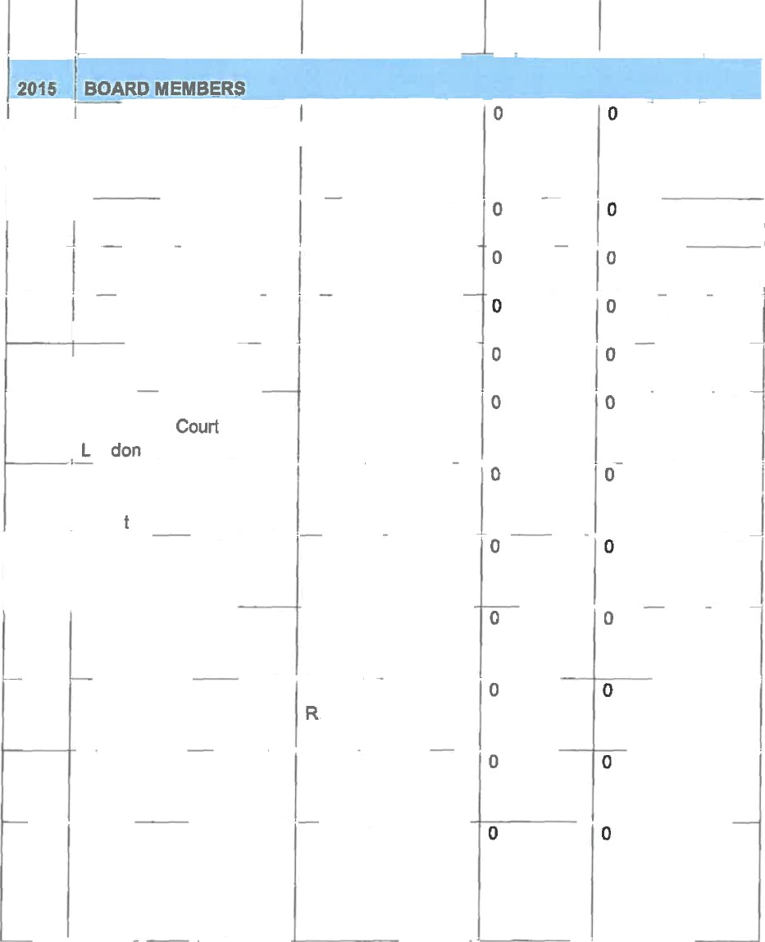
Southern Sun The R 1 830,00 Cullinan

iirchwood Hotel And Or R 1 545,00 'ambo Conference
.entre

Southern Sun Cape Sun R 1 150,00 Southern Sun Cape Sun R 1 150,00 Sunsquare Cape Town R 2 564,00
Sunsquare Cape Town R 2 564,00

Garden East R 1 570,00

on

Southern Sun Katherine R 3 330,00
Stree

Southern Sun Katherine R 726,30

Street

Southern Sun Katherine R 1 395,00
Street

Southern Sun Katherine 1 885,00 Street

Southern Sun Katherine R 1 485,00
Street

Southern Sun Katherine R 2 034,00 Street

hotel

Southern Sun Katherine Street

Park Inn Sandton Park Inn Sandton Park Inn Sandton Park Inn Sandton Park Ann Sandton

Suncoast Hotol
(bb) Cost of (ii) Cost of (iii) Total emount accommodation of shuttle of traveling
each hotel atay

R 1 467,00

R 2 550,00

R 445,00

R 2 550,00

R 338,00

R 1 275,00

R 3 360,00

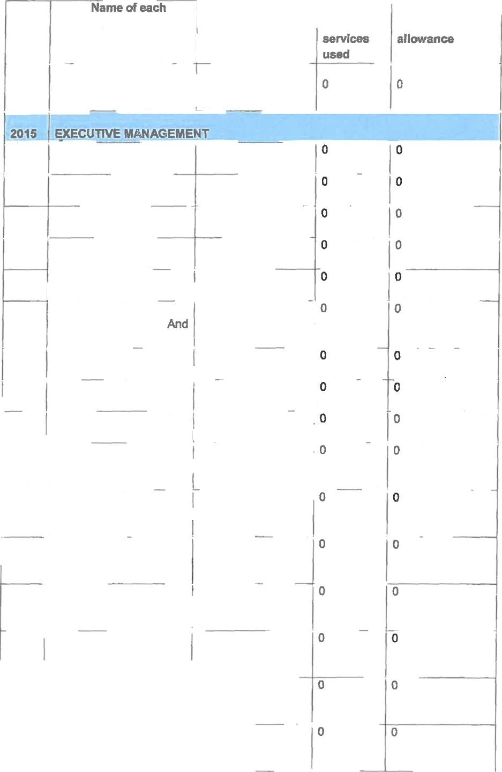
Towem

Protea Hotel Mafikeng R 12 000,00

Protea Hotel Mafikeng R 1 782,80

Hotel Osner R 6 385,00

Southern Sun Elangeni R 1 231.eo

Maharanl
Southern Maharani | Sun | Elangeni , R 4 050,00
Southern  Maharani | Sun | Elangeni R 4 100,00
ahha | Sun | Elangeni R 441,00
Southern | Sun | Elangeni R 4 100,00

Maharanl Southern Sun Elangeni R 441,00
Maharar›i

Southern Sun Elangeni R 4 680,00
Maharani

 | (I)(aa) Name of each  hotel |  |  | (bb) Cost of  accommodation of  each hotel stay | (II) Cost of  shukle services | (iii) Total amount  of traveling allowance
 | Southern Maharani | Sun | Elangeni | R 4 100,00 | 0
 | Southern  Maharani | Sun | Elangeni | R 441,00 | 0 | 0
 | Southern | Sun | Elangeni | R 3 060,00 | 0
 | Maharani
 | Southern Mahaani | Sun | Elangeni | R 662,60 |  | 0
 | Southern  Maharani | Sun | Elangeni | R 3 060,00 |  | 0
 | Southern Maharani | Sun | Elangeni | R 540,60 |  | 0
 | Southern Maharani | Sun | Elangeni | R 3 060,00 | 0
 | Southern  Maharani | Sun | Elangeni | R 410,88 |  | 0
 | Pine Lake Inn |  |  | R 1 000,00 | 0 | 0
 | Southern Maharani | Sun | Elangeni | R 4 590,00
 | Southern Maharani | Sun | Elangeni | R 1 807,00 |  | 0
 | Southern Maharani | Sun | Elangeni | R 4 100,00 | 0
 | Thompsons Holidays |  |  | R 11 696,90 | 0 | 0
 | Garden Parade | Court | Marine | R 1 495,00
 | City Lodge Hotel Sandton Katherine Street |  |  | R 3 940,D0
 | City Lodge Hotel Sandton Katherine Street |  |  | R 2 955,00 | 0

 | (i)(aa) Name of each  hotal | (bb) Cost of  accommodation of aach hotel stay | (ii) Cost of  shuttle seMces  used | (iii) Total amount  of traveling allowance
 | City Lodge Hotel Sandton  Katherine Street | R 871,00 | 0 | 0
 | Premier Hotel East London | R 1 3D0,00 | 0 | 0
 |  | R 1 150,00 | 0 | 0
 | Southern Sun Cape Sun
 | Southern Sun Cape Sun | R 4 200,00 | 0 | 0
 | Southern Sun Cape Sun | R 1 363,48 |  | 0
 | Southern Sun Cape Sun | R 3 034,00 |  | 0
 | Southern Sun Cape Sun | R 5 500,00 | 0 | 0
 | Southern Sun Cape Sun | R 451,50 |  | 0
 | Southern Sun Cape Sun | R 1 150,00 | 0 | 0
 | DMthem Sun Cape Sun | R 1 150,00 | 0 | 0
 | Southern Sun Cape  Sun | R 1 150,00 | 0
 | Southern Sun Cape Sun | R 1 150,00 | 0 | 0
 | Sunsquare Cape Town | R 1 150,00 | 0 | 0
 | Sunsquare Cape Town |  | 0 | 0
 |  | R 1 150,00
 | Sunsquare Cape Town | R 2 452,00 | 0 | 0
 | Sunsquare Cape Town | R 605,92
 | Sunsquare Cape Town | R 1 282,00 | 0 | 0
 | Sunsquare Cape Town | R 1 226,00 | 0
 | Sunsquare Cape Town | R 5 400,00
 | Sunsquare Cape Town | R 579,80 | D | 0
 | Sunsquare Cape Town | R 5 132,00
 | Sunsquare Cape Town | R 5 400,00 | 0

(i)(aa) Nams of each (bb) Cost of (ii) Cost of (iii) Total amount hotel accommodation of shuttle of traveling
r"
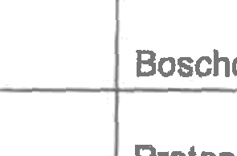
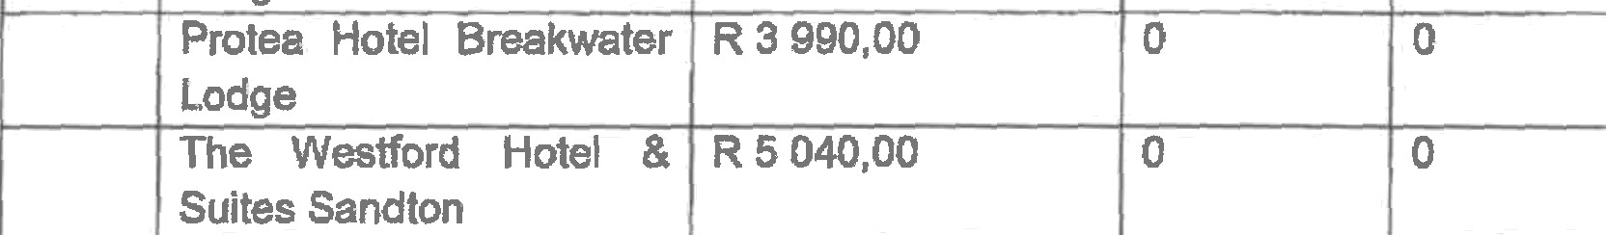
each hotel stay services allowance
used

Sunsquare Cape Town R 533,80

R o f32,60
, 0 0 ,

0 0

Sunsquare Cape Town
0 0
Sunsquare Cape Town R 3 450,00

0 0
Sunsquare Cape Town R 3 450,00

0
0

0
Boschdal Guesthouse R 872,35

0

Protea Hotel Hilton Garden Court East London

R 1 312,00
R 1 680,00 0 0

” "Protea Hotel Breakwater R 1 330,00 Lodge
Protea Hotel Break ter R 3 990,00 Lodge
The Westford Hotel & R 5 040,00 0
Suites Sandton

2016
Protea Hotel Kimberley R 3 111,80
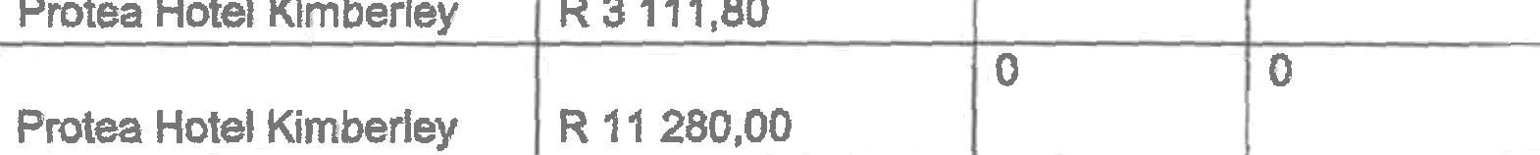
0 iO

Protea Hotal Kimberley R 11 280,00
Cape Town Lodge R 16 000,00 0 0
0
Polokwane Royal Ho e
R 7 200,00
0
0
Mercure Hotel Nelspruit ! R 8 634,15
0
0
Suburban Lodge
R 1 760,00
0
Suburban Lodge
R 1 200,00
0
0
Impa Lala Country Estate R 4 150,00

BOAftD MEMBERS
Southern Sun Katherine ' R 3 070,00 0 0

Street

2016 EXECUTIVE NiANAGEF4ENT
Sunsquare Cape Towrt
R 1 150,00
0
0

0 0
Blue Waters Hotel R 4 782,00

NATIONAL ASSEMBLY

QUESTION POR WRITTEN REPLY

QUESTION NUMBER: PQ 2007 (NW2166E)
DATE OF PUBLICATION: 8 JUNE 2018

s Ncxo no
DEPUTY DIRECTOR-GENERAL: COO
DATE:

N CHAINED
DEPUTY DIRECTOR-GENERAL: STRATEGY AND PLANNING
DATE:3 IF

o n d e

,

HANGAt DIRECTO DATE:

Approved/not approved

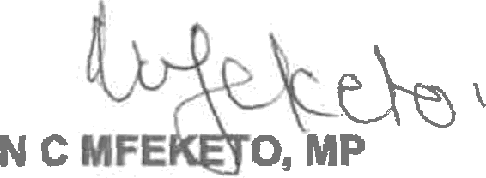
MINISTER FOR HUMAN SETTLEMENTS
DATE: .

