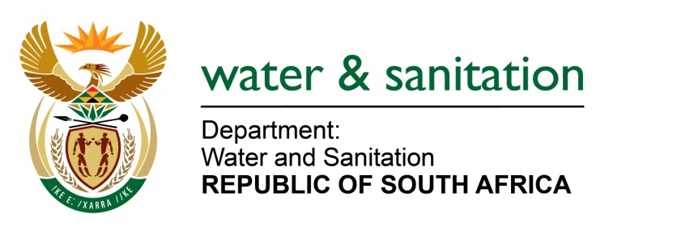

NATIONAL ASSEMBLY

FOR WRITTEN REPLY

QUESTION NO 2007

DATE OF PUBLICATION IN INTERNAL QUESTION PAPER: 23 SEPTEMBER 2016
(INTERNAL QUESTION PAPER NO. 29)

2007. Ms T E Baker (DA) to ask the Minister of Water and Sanitation:

What (a) are the reasons for the recent water shortages experienced in (i) the Emalahleni Local Municipality and (ii) Amsterdam in the Mkhondo Local Municipality in Mpumalanga and (b) steps is her department taking to manage the water shortages in each case? NW2318E
---00O00---

REPLY:

(a)(i) The recent water shortages experienced in Emalahleni Local Municipality was due to the following reasons:

- There were two major leaks on the bulk lines at Oliphant’s Drive main entrance to Bankenveld Golf Estate where the line was leaking back into the Witbank Dam through storm water channel which made it difficult to trace the leak. The second major leak was on the bulk feeder line to Phola/Ogies where fittings were stolen for scrap metals.

- Power failure at the Grobler Substation which affected the pumping of water at Point B which is a feeder reservoir to Point C resulting in water shortages.

- The municipality also depends on mines to augment portable water supply. However, for the last three weeks, the Municipality has not been receiving constant water supply from the mines due to dropping of ground raw water from the mines owing to the drought.

- Whilst the Municipality was experiencing the above mentioned challenges, Point D Reservoir which is the command reservoir was flooded on the night of
11 September 2016 at 23h00 due to a bursting of a pipe in one of the delivery pipe which affected the whole of eMalahleni.

(a)(ii) A valve on the pipeline from the Westoe Dam was broken and after the repair, it took two days for the community to receive water due to reservoirs that should be filled up in the private farms before it could reach the community.

(b) It is envisaged that construction the Mkhondo Bulk Water Supply will start in 2017/18 financial and end in 2019/20 financial year.

In eMalahleni Local Municipality – Currently there is eMalahleni Bulk Water supply under construction. It will be completed in 2018/19 financial year.

---00O00---

